**DEVELOPMENT PROJECT TITLE:**

**UPGRADING OF NGONG BUS TERMINUS**

**BY OBARE LYNNE KOSKE**

**REG: B65/30277/2011**

**UNIVERSITY OF NAIROBI**

**DEPARTMENT OF URBAN AND REGIONAL PLANNING**

**JUNE 2014**

# DECLARATION

This development Project is my original work and has not been presented for a degree in any other university

Signed…………………………… Date…………………………………

LYNNE OBARE KOSKE

(Candidate)

This development Project has been submitted for examination with our approval as the University Supervisors

Signed………………………………… Date………………………………..

Professor Ndengwa

(Supervisor)

# ABSTRACT

Ngong town is an urban area which is highly dominated by residential land use. The residential land use has attracted more activities and services so as to satisfy the needs of the residents. Due to this, there is growth in concentration of economic activities and public transport within the town centre. The spaces that were designated for public transport use and economic use are outgrown, thereby occupying the road reserve. Some Public transport vehicles are operating from the road reserve where passengers board and alight because the formal terminus cannot provide adequate spaces for parking. The market and the bus terminus are well centralized to enhance accessibility from other various parts of Ngong town. Some few years ago when the public transport vehicle had not increased in numbers, there was sufficient space for parking at the existing bus terminus and even some spaces could just be left unoccupied. The unoccupied spaces attracted the traders and these traders decided to use them for business purposes since there is no clear boundary between the market and the bus terminus. Traders tend to take the advantage of this situation by occupying the spaces that are preserved for parking. After some time the public transport vehicle also increased and the parking challenges started to be experienced by public operators making them to seek other alternative ways. There is a lot of pressure between the public transport operators and the traders on the issue of space occupation.

The aim of this development project is to provide solutions to the challenges and the difficulties of Ngong town are experienced as a result of inadequate parking spaces at the bus terminus. The paper gives a clear strategy that will be adopted to curb these issues and concerns. The following steps were considered in design process

* Problem identification and detailed situational analysis
* Design of the alternative proposals and Selection of the preferred alternative
* A detailed framework for implementation of the project
* And lastly monitoring and evaluation of the project.

The project focuses to upgrade Ngong bus terminus and give recommendation on the ways to improve the market condition by providing a two storey stalls which will create more space and remedy the pressure between public transport and traders and also stop the occurrences of future informal bus terminus. The project will provide appropriate design for market and the bus terminus which will be able to accommodate all the public transport vehicles so that the occurrences of future informal bus terminus may be avoided and minimize traffic congestion within the surrounding of the terminus. The development project will provide a proposed land use plan for the selected section so that a clear framework will be adopted for the stages of implementation, monitoring and evaluation of the project. The area which the problems will be fixed by the development project is addressed is within the CBD of Ngong town along the road reserve of the main road. The development project will provide appropriate framework which will remedy the inherent problem of informal bus terminus on contested spaces

# ACKNOWLEDEMENT

I like to acknowledge God first who has favored me all this time by giving me knowledge, strength and peace and good times throughout this project and my entire academic progress. Then my honest gratitude goes to PROFESSOR ELIJAH NDENGWA for guiding me through all this process of doing project and ensuring the best of me. Thanks also to the entire Department of Urban and Regional Planning and the City Council of Nairobi for their continuous support. I also thank my family and friends for the moments they have spent with me and the support they provided to make me have easy time in my academic.

Contents

DECLARATION ii

ABSTRACT iii

ACKNOWLEDEMENT iv

CHAPTER ONE 1

INTRODUCTION 1

1.1. OVERVIEW 1

1.2. PLANNING RESEARCH PROJECT TITLE 1

1.3. SUMMARY OF THE MAIN FINDINGS 1

1.3.1. INCREASED PUBLIC TRANSPORT 1

1.3.2. OCCURRENCE OF NUMEROUS TRADING ACTIVITIES WITHIN THE BUS TERMINUS 1

1.3.3. INADEQUACY PARKING SPACES 2

1.3.4. LONG BUS QUEUES LEADIND TO DELAYS 2

1.3.5. EXTREME DEMAND VARIATION FOR PUBLIC TRANSPORT AT DIFFERENT TIMES OF THE DAY 2

1.4. SUMMARY OF THE MAIN RECOMMENDATION OF THE PLANNING REASERCH PROJECT 2

1.4.1. RE-ORGANIZATION OF THE LAND USE STRUCTURE WITHIN THE BUS TERMINUS AND THE MARKET AREA 2

1.4.2. TO UPGRADE THE EXISTING NGONG BUS TERMINUS 3

1.4.3. TO IMPROVE MARKET CONDITION BY PROVIDING STALLS 3

1.4.4. INTEGRATING LAND USE AND TRANSPORTATION PLANNING 3

1.4.5. TO PROVIDE EFFECTIVE ON-STREET PARKING SPACES 3

1.4.6. FREQUENT ASSESSMENT OF CHANGES IN DEMAND FOR PARKING SPACES 3

1.4.7. RESPONDING TO CHANGES IN TRANSPORTATION DEMANDS 3

1.4.8. INVOVEMENT OF INSTITUTIONS AND STAKEHOLDERS 4

1.4.9. PROVIDE DECELERATION LANE CONNECTING THE TERMINUS 4

1.5. STATEMENT OF THE DEVELOPMENT PROJECT TITLE 5

1.6. REASONS FOR CHOOSING THE DEVELOPMENT PROJECT 5

1.7. LOCATION AND THE AREA COVERAGE BY THE DEVELOPMENT PROJECT 7

1.8. OBJECTIVES OF THE DEVELOPMENT PROJECT 8

1.9. ASSUMPTIONS OF THE DEVELOPMENT PROJECT 8

1.10. SCOPE OF THE DEVELOPMENT PROJECT AND THE ORGANIZATION OF THE PROJECT CHAPTERS 8

1.10.1. SCOPE OF THE DEVELOPMENT PROJECT 8

1.10.2. THE ORGANIZATION OF THE PROJECT CHAPTERS 8

1.11. RESEARCH METHODOLOGY FOR DEVELOPMENT PROJECT 9

1.12. DATA NEEDS AND REQUIREMENTS 9

1.13. DATA SOURCES 9

1.14. METHODS OF DATA COLLECTION 10

1.14.1. PRIMARY DATA 10

1.14.2. SECONDARY DATA 10

1.15. METHODS OF DATA ANALYSIS 11

1.16. METHODS OF DATA PRESENTATION 11

1.17. LIMITATIONS 11

1.18. DATA NEEDS MATRIX 11

1.19. DEFINITION OF KEY TERMS AND CONCEPTS 12

CHAPTER TWO 14

REVIEW OF POLICY GUIDELINES 14

3.1. OVERVIEW 14

3.2. POLICY FRAMEWORK 14

3.2.1. KENYA VISION 2030 14

3.2.2. NATIONAL LAND POLICY 15

3.2.3. INTEGRATED TRANSPORT POLICY 16

3.2.4. THE 1973 NAIROBI METRO PLAN 19

3.2.5. THE NAIROBI METRO 2030 STRATEGY 20

3.3. LEGAL FRAMEWORK 20

3.3.1. THE CONSTITUTION OF KENYA (2010) 20

3.3.2. URBAN AREAS AND CITIES ACT 20

3.3.3. COUNTY GOVERNMENT ACT (2011) 20

3.3.4. PHYSICAL PLANNING ACT (1996) 22

3.3.5. ENVIRONMENTAL MANAGEMENT AND COORDINATION ACT (1999) 22

3.3.6. PHYSICAL PLANNING HANDBOOK 22

2.7. REGULATORY FRAMEWORK, GUIDELINES, PLANNING AND DESIGN STANDARDS 23

2.8. CASE STUDY 28

CHAPTER THREE 32

SITUATIOANAL ANALYSIS 32

3.1. OVERVIEW 32

3.2. THE LOCATION CONTEXT OF THE PROJECT AREA 32

3.3. BACKGROUND OF THE PROJECT AREA AND ITS HISTORICAL CONTEXT 33

3.4. SITE ANALYSIS: 33

3.4.1. TOPOGRAPHY AND NATURAL ENVIRONMENT CHARACTERISTICS 33

3.4.2. GEOLOGY AND SOILS 33

3.4.3. SOILS 35

3.4.4. RAINFAL 36

3.4.5. RIVERS 36

3.4.6. TEMPERATURE 36

3.4.7. WINDS 36

3.4.8. SUN AND WIND PATHS 38

3.4.9. VEGETATION 39

3.5. POPULATION AND DEMOGRAPHIC CHARACTERISTICS OF THE PROJECT AREA 39

3.5.1. POPULATION CHARACTERISTICS 39

3.5.2. SOCIAL ECONOMIC CHARACTERISTICS 39

3.5.3. CULTURAL AND POLITICAL PROFILE OF THE POPULATION 40

3.6. INSTITUTIONAL FRAMEWORK 40

3.7. LAND USE ANALYSIS 41

CHAPTER FOUR 44

PROJECT PLANNING DESIGN AND IMPLEMENTATION 44

4.1. OVERVIEW 44

4.2. PLANNING AND DESIGN OF THE PROJECT 44

4.3. EXPECTED OUTPUTS AND OUTCOMES OF THE DEVELOPMENT PROJECTS 46

4.4. DEVELOPMENT OF THE SPATIAL PLAN 47

4.5. DESIGN OF ALTERNATIVES 48

4.6. SITE PLANNING/DESIGN AND DEVELOPMENT PROCESS STAGES 52

4.7. DEVELOPMENT OF DETAILED ACTION PLAN 56

4.8. POPULATION PROJECTION 58

4.9. LAND BUDGET PROPOSAL 59

4.10. IMPLEMENTATION STRATEGIES 59

4.11. IMPLEMENTATION SCHEDULE 60

CHAPTER FIVE 62

MONITORING AND EVALUATION 62

5.1. OVERVIEW 62

5.2. MONITORING AND EVALUATION STAGES IN THE IMPLEMENTATION OF PROJECT 62

5.3. EVALUATION OF THE PROJECT 62

5.3.1. MID TERM EVALUATION PHASE 62

5.3.2. TERMINAL EVALUATION PHASE 62

5.3.3. POST IMPLEMENTATION EVALUATION PHASE 62

5.4. GUIDELINES FOR THE IMPLEMENTATION PROCESS 65

5.5. SITE /ENVIRONMENTAL MANAGEMENT PLAN 65

5.6. CONCLUSION 66

BIBLIOGRAPHY/ REFERENCES 67

APPENDICES 69

LIST OF MAPS

Map 1: situational analysis map 10

Map 2: locational site of the development project 12

Map 3: site 12

Map 4: Nairobi metropolitan map 25

Map 5: site at national context 36

Map 6: site at neighborhood context 36

Map 7: site at local context 36

Map 8: topographical map of Ngong town 37

Map 9: geological map of Ngong region 38

Map 10: map showing wind path within the site 41

Map 11: sun path of the project area 42

Map 12: land use analysis map of the site 45

Map 13: situational analysis map 59

LIST OF FIGURES

Figure 1: transport management in Kenya 24

Figure 2: conceptual guide to plan preparation 29

Figure 3: center aligned bus terminus 30

Figure 4: features of bus environment 32

Figure 5: locating a bus terminus 49

Figure 6: development of the spatial plan 51

Figure 7: conceptual guide for plans preparation 53

Figure 8: planning process 61

LIST OF TABLES

Table 1: data need matrix 17

Table 2: expected output and outcomes of the development project 50

Table 3: cost benefit matrix 55

Table 4: goal achievement matrix 57

LIST OF PLATES AND CHARTS

Plate 2: Ferralochromic soils 39

Plate 3: Ferralic lurisols 39

Plate 4:Mollic andosols soils 40

Plate 5: orthic rendzinas 40

Plate 6: wind mask 41

Plate 7: the angle of the solar incidence of the site 43

Plate 8: Ngong hills forest reserve 43

# CHAPTER ONE

# INTRODUCTION

## OVERVIEW

The main aim of this chapter is to outline the project title of the planning research, summary of the main findings from the planning research project, the recommendation of the planning project, Statement of the development project title, reasons for choosing the development project, location and the area coverage by the development project, objectives of the development project, assumptions of the development project, scope of the development project and the organization of the project chapters, research methodology for development project, data needs and requirements, data sources, methods of data collection, methods of data analysis, methods of data presentation, limitations, data needs matrix and finally the definition of key terms and concepts

* 1. PLANNING RESEARCH PROJECT TITLE: IMPLICATION OF INFORMAL BUS TERMINUS ON NGONG ROAD RESERVE (SECTION WITHIN THE CBD OF NGONG TOWN)

## SUMMARY OF THE MAIN FINDINGS

### INCREASED PUBLIC TRANSPORT

The town has been experiencing rapid population growth and urbanization from both natural population increase and high rates of migration into Ngong town. Due to this effect of increase in population, demand for public transport has also increased so that it can satisfy the transport needs of the passengers. Matatus are the most common form of public transport in Ngong town. Majority of these Matatus are privately owned and the most popular form of local transport. The current bus terminus cannot accommodate all the public transport vehicles which operate from Ngong town because the numbers of the matatu operators have increased. This has resulted in the emergency of informal bus terminus on the road reserve in a section within the CBD of Ngong town. This informal bus terminus is actually located opposite the existing bus terminus. The emergency of this informal bus park has created uncoordinated traffic flow within causing traffic jams as motorist try to get out of gridlocks especially in the peak hours.

### OCCURRENCE OF NUMEROUS TRADING ACTIVITIES WITHIN THE BUS TERMINUS

The market and the bus terminus are centralized to enhance accessibility from other parts of Ngong town. The market is linked with the bus terminus directly in terms of space. There is no clear boundary between the market and the bus terminus. Traders tend to take the advantage of this situation by occupying the spaces that are preserved for parking. This makes the public service vehicle not to have sufficient parking spaces forcing them to occupy areas that are not designated for bus terminus. Another challenge is the design of the bus terminus and the connection of the terminus to the road which is poorly developed because when the public transport vehicles exit the terminus they generate a lot of traffic congestion and sometimes when people board the buses at the terminus, these vehicles park very close to the road posing a danger such as accidents. The main is relatively narrow road that passes at the terminus is narrow and the pedestrian lane is not well provided.

### INADEQUACY PARKING SPACES

The informal bus terminus has been created by the matatu operators because the current bus terminus cannot be able to provide spaces for parking to all the buses since the buses have out grown the spaces that are available. The points where informal matatu terminus is operating tend to cause problems such as congestion and interference with pedestrian movements.

### LONG BUS QUEUES LEADIND TO DELAYS

Due to Over-reliance on one mode of transport is also another problem. Since increase in population creates a good market for public transport vehicle to offer services, long queues are being experienced at the existing bus terminus and the inadequacies of parking spaces pushes the public transport operators to look for other alternatives. Because of stiff competition between the public transport operators in making more money, the creation of informal bus terminus was considered as the best alternative that was to provide extra parking spaces for public service vehicles and to minimize time wasted as a result of long queues.

### EXTREME DEMAND VARIATION FOR PUBLIC TRANSPORT AT DIFFERENT TIMES OF THE DAY

The nature of demand that tends to vary throughout the day. The demand for most urban public transport in Ngong town is very peaked, with high utilization during the mornings and early in the evenings. The situations are experienced in the market days such as Saturdays and From Monday to Friday. This poses considerable problems for operators. Vehicle fleets must be adequate to meet these peaks in demand.

## SUMMARY OF THE MAIN RECOMMENDATION OF THE PLANNING REASERCH PROJECT

To effectively respond to the above findings, the following are recommended:

### RE-ORGANIZATION OF THE LAND USE STRUCTURE WITHIN THE BUS TERMINUS AND THE MARKET AREA

It will aim at improving the various activity spaces so that to enhance compatibility of between land-uses within the study area. The study area being a center hub for public transport that supports the operation of the market both formal and informal, commercials and residential areas, the re-organization will promote its productivity in terms of social needs, economic needs and even environmental needs.

### TO UPGRADE THE EXISTING NGONG BUS TERMINUS

The expansion of the bus terminus will provide extra parking spaces and will facilitate the public transport vehicle. The terminus will be expanded by reclaiming the spaces that have been taken by the traders who believed that the section of the terminus they have occupied is part of the market. The traders will be relocated and accommodated within the main market. For traders o effectively accommodated, a two storey stalls needs to be constructed so as to create more space and remedy the pressure between public transport and traders and also stop the occurrences of future informal bus terminus.

### TO IMPROVE MARKET CONDITION BY PROVIDING STALLS

The pressure between public transport and market traders is causing an alarming issue that needs to be addressed urgently. Considering the market is an open air market, provision of a two storey stalls can increase the capacity of space used. This will minimize the pressure between traders and public transport on the issue of space use. Other factors like encroachment will also be minimized. This will reduce the pressure between the public transport operators and the traders on the issue of space occupation

### INTEGRATING LAND USE AND TRANSPORTATION PLANNING

The urban transport planning is a complex activity. The integration of land use and transport planning will enable the development of a plan that will facilitate transport facilities are provided with adequate parking spaces in all various activity spaces so as to avoid congestion.

### TO PROVIDE EFFECTIVE ON-STREET PARKING SPACES

The current space that is used by the public transport bus terminus is not enough to accommodate all the public transport vehicles because the transportation demand is so high. There is need to create more parking at the bus terminus to avoid the existence of informal bus terminus on the road reserve.

### FREQUENT ASSESSMENT OF CHANGES IN DEMAND FOR PARKING SPACES

Carry out frequent research to assess the changing demand for parking spaces due to continual rise in demand for public service vehicles. In this manner, the difficulties in parking spaces will be unlikely deficient.

### RESPONDING TO CHANGES IN TRANSPORTATION DEMANDS

A policy control needs to be implemented and formulated that will allow the maximum number of public service to vehicle within the CBD of the town so that to avoid extreme congestion. It will be effective if the county government will prepare the budget articulating for the changes in demand for public service vehicles and allocating extra land for the expansion of transport facilities.

### INVOVEMENT OF INSTITUTIONS AND STAKEHOLDERS

The institutions play different roles and responsibilities. There is need for re-organizing transport institutional framework that will cater for transportation needs within Ngong town. Ngong town is under the county government of Kajiado. Kajiado county government is the leading institution that governs any development within it is boundaries. Any development provisions in county governments are outlined and guided with the requirements of urban areas and cities act of 2011, physical planning act and county government act.

### PROVIDE DECELERATION LANE CONNECTING THE TERMINUS

The design of the terminus and the connection of the terminus to the road is poorly developed because when the public transport vehicles exit the terminus they generate a lot of traffic congestion and sometimes when people board the buses at the terminus, these vehicles park very close to the road posing a danger such as accidents. The main road that passes at the terminus is relatively narrow and the pedestrian lane is not well provided. The need to provide a service lane is important because it will reduce the problems of congestion and reduce the chances of accidents.

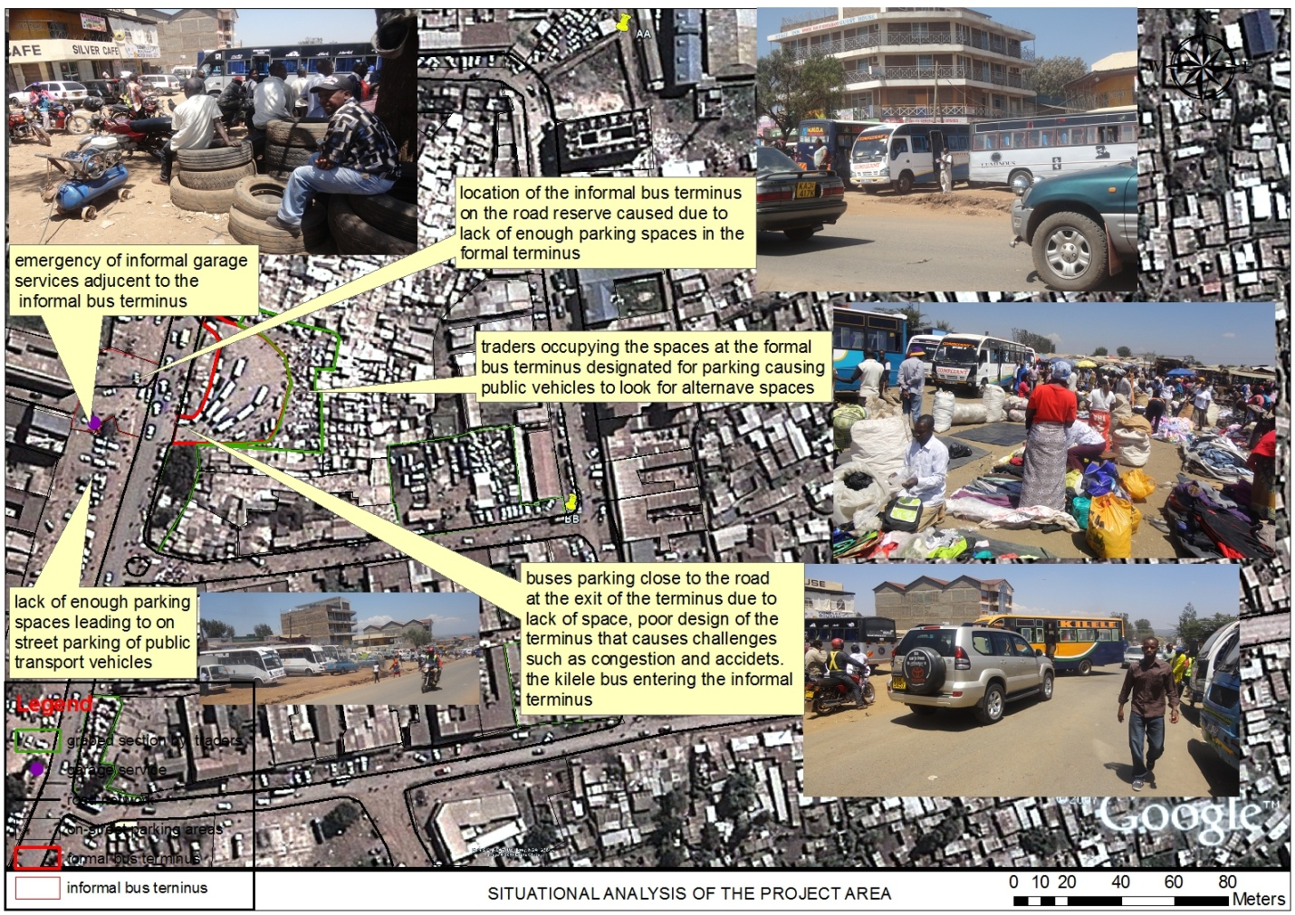

Map 1: situational analysis map

Map 2: major roads around the bus terminus

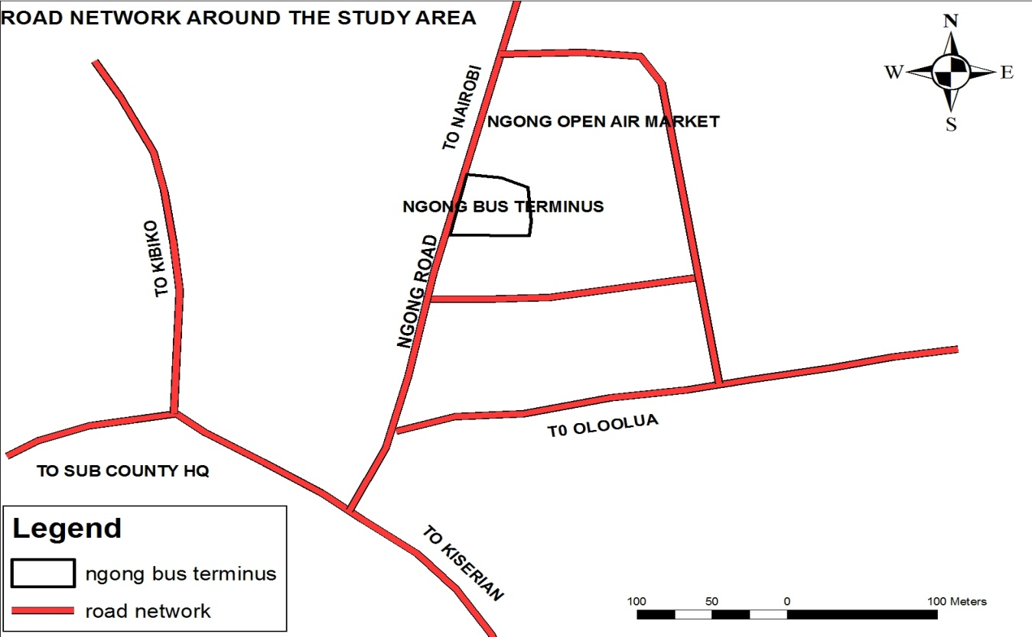

Source: adopted from Google image by author

## STATEMENT OF THE DEVELOPMENT PROJECT TITLE

The upgrading of Ngong bus terminus

## REASONS FOR CHOOSING THE DEVELOPMENT PROJECT

From the in-depth analysis as addressed from planning research project, it is evident that the development of public service vehicle bus terminus requires proper implementation of programmes and policies.

Transportation facilities e.g. bus terminus and land usage are inseparable and should ideally be considered in a single, all embracing, urban plan. The increased level of public transport and the continual rise in the urban population is causing considerable alarm in the town. Since the market and current bus terminus provides a close and a suitable linkage and easy accessibility to the users, there is need to expand the bus terminus so as to stop the continuing increase of informality in urban transport and reduce the pressure on contested spaces. For this reason planning is essential; the provision of alternative location for matatu operators and how different approaches can be used to minimize future informal matatu stage.

The weak institutional framework is also another leading factor that has facilitated the emergency of the informal bus terminus. There is improper governance in the management and administration of the institutions. The institutions have failed to enforce the required control measures to remedy the problems of informal bus terminus and even the key stakeholders are very reluctant in helping to address those critical issues.

## LOCATION AND THE AREA COVERAGE BY THE DEVELOPMENT PROJECT

The informal bus terminus is located on the road reserve in a section within the CBD of Ngong town. This informal bus terminus is actually located opposite the existing bus terminus. The development project will cover an area of 0.46ha. This area will necessitate the upgrading of the existing bus terminus so that the existence of informal bus terminus on the road reserve will be will terminate to function. The traders who have occupied the bus terminus space will be evacuated. This will be used as an alternative area to replace the informal public service vehicle bus terminus.0.168ha

Map 3: locational site of the development project

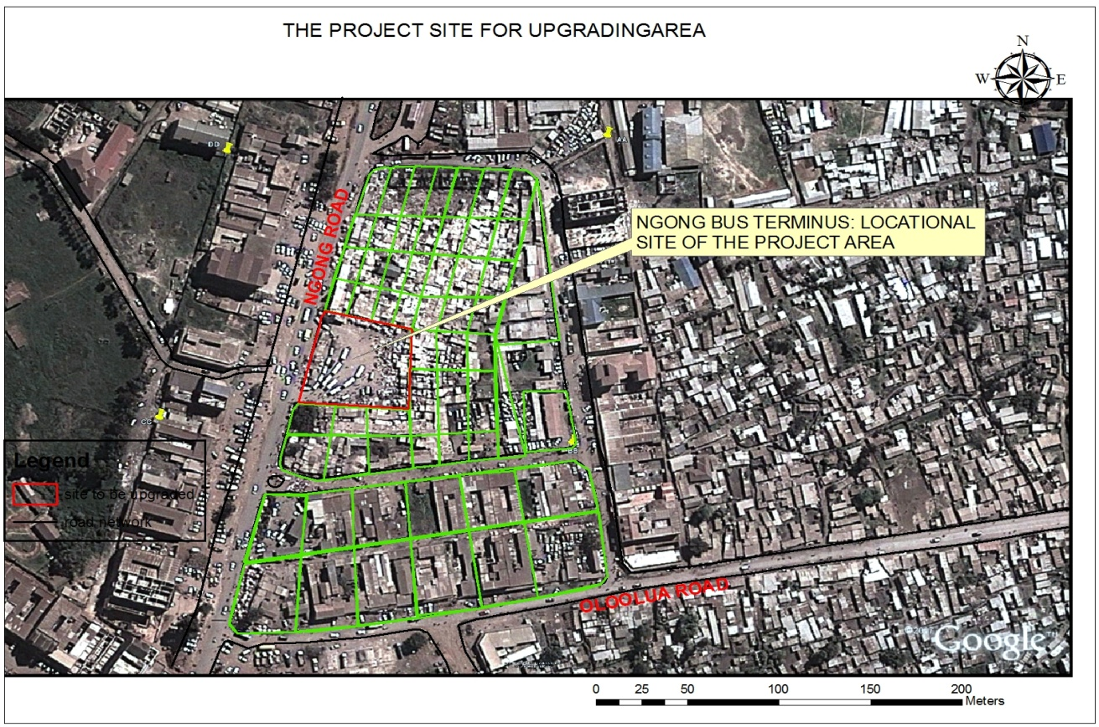

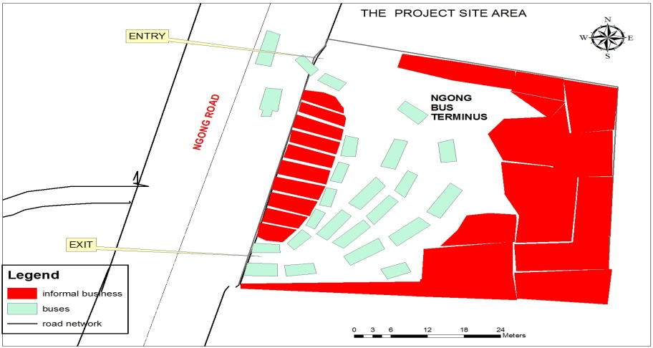

Map 4: site source; author

## OBJECTIVES OF THE DEVELOPMENT PROJECT

1. To formulate a coherent land use plan around Ngong bus park that will facilitate the re-organization of various land-uses around the bus terminus
2. To come up with proper designs for the upgrading of proposed bus terminus that will be the basis for effective transport system
3. To propose and give recommendation on the re-organization and upgrading of the market.
4. To provide a good framework for the implementation of the project through application of an effective monitoring and evaluation procedures

## ASSUMPTIONS OF THE DEVELOPMENT PROJECT

1. The upgrading of Ngong bus terminus will provide adequate parking spaces for vehicles.
2. The problems of congestion will reduce within the bus terminus

## SCOPE OF THE DEVELOPMENT PROJECT AND THE ORGANIZATION OF THE PROJECT CHAPTERS

### SCOPE OF THE DEVELOPMENT PROJECT

The project focuses to upgrade Ngong bus terminus and improve the market by providing a two storey stalls which will create more space and remedy the pressure between public transport and traders and also stop the occurrences of future informal bus terminus. The project will provide appropriate design for market and the bus terminus which will be able to accommodate all the public transport vehicles so that the occurrences of future informal bus terminus may be avoided and minimize traffic congestion within the surrounding of the terminus. The development project will provide a proposed land use plan for the selected section so that a clear framework will be adopted for the stages of implementation, monitoring and evaluation of the project. The area which the problems will be fixed by the development project is addressed is within the CBD of Ngong town along the road reserve of the main road. The development project will provide appropriate framework which will remedy the inherent problem of informal bus terminus on contested spaces

### THE ORGANIZATION OF THE PROJECT CHAPTERS

#### CHAPTER 1: INTRODUCTION

The introduction part of the report gives the summary of the main findings and the summary of the recommendations of the planning research project, statement of the development title, reasons for choosing the development project, location and area coverage of the project area, objectives of the development project and assumptions of the development project and finally the methodology section of the project.

#### CHAPTER TWO: POLICY REVIEW

The chapter two is concerned with review of policy documents, regulatory frameworks, planning standards, conceptual framework, and theoretical framework. Also the case studies of various locations experiencing similar effects were considered.

#### CHAPTER 3: SITUATIONAL ANALYSIS OF THE PROJECT AREA

The chapter entails the physical location of the study area in respect of national level, the regional level and finally the local contexts. Landscape or topographical and environmental characteristics of the area, background information in terms of the history, planning and development of the area, the population characteristics, land use analysis and lastly institutional, legal and financial issues of the project area.

#### CHAPTER 4: PROJECT PLANNING, DESIGN AND IMPLEMENTATION

Chapter four shows the planning process, alternative plans and designs, expected outputs and outcomes of the project and implementation strategies and programs for the project.

#### CHAPTER 5: MONITORING AND EVALUATION

The chapter articulates the monitoring and evaluation procedures in the implementation of the project, and eventually the site/Environmental Management Plan.

## RESEARCH METHODOLOGY FOR DEVELOPMENT PROJECT

The research methodology for the development project provides a systematic framework for undertaking the project. From the development project objectives, the kind of data to be collected was described so that the requirements of the project are achieved. The data analysis methods were also considered for effective data output. Lastly the summary of the whole process of methodology is shown by the data needs matrix for further understanding.

## DATA NEEDS AND REQUIREMENTS

The data needs and the requirements of the project was established from the policy documents, documents which provide legal framework for the developments controls of land uses, zoning, planning standards and also considering the relevant case studies for further information.

## DATA SOURCES

The major data sources were acquired from both primary sources and secondary sources. The primary sources were collected through the use of interview schedules for the key informants, field sketching, observation and taking images (photography). The secondary data was divided into two, namely; the policy documents and legal documents. The materials that were used for the policy documents data were; The 1973 Nairobi metro plan, the Nairobi metro 2030 strategy, regional development policy 2007, draft integrated national transport policy of 2003, the Kenya vision 2030, national land policy (2009), Nairobi metro 2030 (2009), draft national urban development policy (2012), integrated Kenya national transport draft policy (2009)

On the legal documents were; The constitution of Kenya (2010), physical planning act (1996), local government act (cap 265), devolved government act (2011), urban areas and cities act (2011), national land commission act (2012), environmental management and coordination act (1999), Kenya roads act (2007), traffic (amendment) act (2012), physical planning handbook and eventually the land acquisition act. Information on Population and demographic was acquired from the Kenya National Housing and Population Census Report (2009). This information facilitated the population projection that is anticipated to be accommodated by the project. The Physical Planning Handbook (2008) provided a planning framework standard for the project. Also the A.J. Metric Handbook and the Building Code were considered for more information.

## METHODS OF DATA COLLECTION

### PRIMARY DATA

#### INTERVIEW SCHEDULES

The respondents of this interview schedules were the stake holders of matatu owners associations who were the key informants.

#### OBSERVATION SCHEDULES

The observation schedule was done inform of a list that contain some variables which were recorded down. The aspects which were recorded down were; the amount of space that was used by the informal bus terminus, the number of public service vehicles that were accommodated at various time of the day, traffic congestion that was to be generated at the point where the informal bus terminus was located.

#### PHOTOGRAPHY

Pictures were taken to show the exact evidence of what is happening in the study area. Also other competing interests of activities were captured to show how the land use pattern in Ngong town has been created. The location of the informal bus terminus, traffic generated by informal bus terminus, the size of the road width among others were captured too.

#### SKETCHING

When the researcher visited the site, some sketches were done to show the illustrations of the informal bus terminus. These included the cross-sections of the road reserve, informal markets, the current bus terminus and the formal market itself.

### SECONDARY DATA

The secondary information was extracted from the review of relevant policies, acts, various case studies and designs documents which provides the guidelines for planning and designing of the bus terminus.

## METHODS OF DATA ANALYSIS

The data that was collected from the field was synthesized and analyzed for the purpose of interpretation and presentation. There were both qualitative data and quantitative data. The Spatial data was also acquired for analysis. This data was analyzed using GIS software and the AutoCAD. The Microsoft Excel and SPSS were used for the analysis of quantitative and qualitative data.

## METHODS OF DATA PRESENTATION

After the data collection and analysis has been done, the data will be presented in tow forms

1. continuous data
2. categorical

Categorical data was presented inform of fraction e.g. $1\frac{1}{2}$ hours and the continuous data was presented in form of bar graphs and pie charts

## LIMITATIONS

During the research, some limitations emerged such as;

1. It was difficult to acquire some information from the public about the terminus.
2. There were constraints in finances.
3. Some of the local authority refused to be interviewed.

## DATA NEEDS MATRIX

Table 1: data need matrix

|  |  |  |  |  |
| --- | --- | --- | --- | --- |
| OBJECTIVES | DATA NEEDS | FORM | USE OF DATA | SOURCE |
| To formulate a workable mechanism that will facilitate the re-organization of various land-uses around the bus terminus | -the goals of policy and legal framework in land use planning for transportation in urban areas.  -planning guidelines and standards for different land uses. | Qualitative and descriptive forms  -Qualitative and descriptive forms | -To provide a legitimate legal framework for planning in transport system.  - To provide a guideline for planning of transport system with respect to other land uses. | -legal documents such as the Kenyan Constitution 2010, the acts of Parliament, the Physical Planning Handbook and finally the various policies |
| To come up with proper designs of the proposed bus terminus that will be the basis for effective transport system | -information on land use in the study area.  -the linkage pattern and location of the bus terminus.  - The degree of traveling patterns and the characteristics and the size of the population within the study area. | -spatial form.  -Spatial form.  -Quantitative form | -preparing a transport land use map.  -to determine the relationship in the linkage of the road networks and the bus terminus  -to provide information on the adequacy of supply and demand of public transport vehicles. | -Researcher acquiring the information from the ground, national census and demographic reports, information from plans addressing transport system. |
| To propose and give recommendation on the re-organization and upgrading of the market. | - The Models of integrated transport land use. | - Qualitative and descriptive forms | -to provide a guideline for integrating transport and other land uses. | Review of documents that address the integration of transport and other land uses. |
| To provide a good framework for the implementation of the project through application of an effective monitoring and evaluation procedures | -The role of various institutions in transport planning.  -Community and stakeholder’s participation. | -Qualitative and descriptive  -Qualitative and descriptive | To understand the role that is to be played by various bodies in implementation of the project through monitoring and evaluation | -The Kenya Constitution 2010  -Acts of Parliament and relevant policies  -Physical Planning Handbook  And other relevant documents |

## DEFINITION OF KEY TERMS AND CONCEPTS

**Land use planning**

* This is an exercise which designates and regulates the use of land so as to enhance the well being of the society through the efficiency of economy, physical and eventually the social aspects.

**Bus terminus**

* This refers to a facility that enables the public transport vehicles to board and alight safely and secure. It also allows the public transport vehicles to park and receive some minimal services.

**Sustainable transport system**

* Refers to a transport system that can be able to meet both the present needs and the future needs of passengers in an effective manner.

**Public transport vehicles**

* Public transport is a shared passenger transportation service which is available for use by the general public, as distinct from modes such as taxicab, car pooling or hired buses which are not shared by strangers without private arrangement (Banks, 1998).

**Transport**

* Transport refers to the linkage between the activities spaces (Obiero, 1992).

**Matatu**

* Is a local word that is used to refer public service vehicles.

**Transport demand**

-Refers to the needs of transport system that is required by the transport users

**Matatu operators**

-These are the people who are employed to offer services such as being drivers and conductors of the public service vehicles

# 

# CHAPTER TWO

# REVIEW OF POLICY GUIDELINES

## OVERVIEW

The aim of this chapter, it focuses on providing the planning policies, plans, design guidelines and standards that will be used as a framework in the development project in designing of a bus terminus. The chapter also provides the information on various case studies that had similar experience.

## POLICY FRAMEWORK

### KENYA VISION 2030

The Kenya vision 2030 is a long term development plan for Kenya. This plan aims to improve the economic growth of the country and the general welfare of all Kenyans. The plan also encourages the need for sustainable environment by trying to reach the requirements of the millennium development goals. The vision is used as a framework for the development of various flagship projects in the country such as;

**A 50 year integrated national transport plan**

The main aim for this plan is to make the country a transport hub by providing a sustainable national transport system. The plan aims to improve and expand the transportation infrastructures in a way to minimize the costs and create a room for more economic development. The plan addresses the need for integrating the entire transport infrastructure with various land use. Proper integration of road network, railway network, air transport network, ports and terminal facilities will promote the national desire for the development of socio-economic. The plan provides a decision making framework for investment in transportation infrastructure that will be used by both the government and private sectors in duration of 50 years. The plan has also a guideline that encourages institutional capacity building in maintaining and managing transportation infrastructures such as roads, railway, ports, terminal facilities and even water. The main aim of encouraging institutional capacity is to enhance the effectiveness and efficiency in delivery and access of services and revenue generation. The plan requires that, the institutions which will be responsible for maintaining and managing the transport infrastructure to provide quality services.

**Infrastructure**

Infrastructure is the backbone for the development of any region. The vision aims to provide a good linkage of roads, water ways, railway, telecommunication and terminal facilities such as bus stops, bus terminus, and ports and even air ports so that a sustainable infrastructure can be realized in the country. Provision of proper sanitation facilities and supply of portable water is also another priority.

**Land reforms**

Land is one of the crucial and critical resource for the development of socio-economic aspects and political aspects in the country. It is highly valued in Kenya even before and after indepence. The vision mainly relies on the national land use policy. The policy encourages proper use of land by ensuring the developments do not become injurious to the land. The policy provides a basis for land administration, a legal framework for settling land disputes and issues and finally the provision of national spatial data for tracking the land use patterns in the country.

**Transparency and accountability**

The vision encourages all the government institutions to adopt good ethics through transparency and accountability. Transparency and accountability can be achieved through the following guidelines

1. Ensuring the legal framework for anticorruption is fully considered and strengthened
2. Allowing the members of the public to access data and information.
3. Strengthening the legislative oversight capacity of the parliament
4. Ensuring that the civilian oversight is created around the security institutions and the justice institutions

The Kenya vision 2030 is to be used as an engine to accelerate infrastructure developments that are still in progress by ensuring the developments are of high quality, promote social equity and also which can contribute towards economic growth of the country. Another aim of the vision is to enhance the effectiveness and efficiency in the development of infrastructure from the stages of planning, contracting, and eventually construction. In achieving the infrastructure development goals, some crucial strategies have been put forward.

1. Empowering the institution framework responsible for infrastructure development by accelerating the speed of completion
2. Increasing the efficiency and the quality of the development project and ensuring the implementing pace of the project are realized within the said time frame.
3. Ensuring the integrated transport system is safe, effective and efficient.

### NATIONAL LAND POLICY

The national land policy is a document that guides the country on the usage of land. This document also allows equitable and sustainable use of land. In Kenya land is categorized in three sections namely; private land, community land and public land. Private land is the one which is owned by individuals either freehold or under leasing. Community land is the one which is designated for only community purpose and is managed by the community. Public land is the land which is owned by government and allocated for specific public use. The document was formulated to deal with critical issues such as land use planning, land administration, environmental degradation, access to land, land conflicts, outdated legal framework, unplanned proliferation of informal urban settlements, information management, restitution of historical injustices and finally land institutional framework.

**Principles for land use planning**

According to national land policy, it defines Land use planning as the preparation and actualization of spatial frameworks for orderly management of human activities. Land use plans are prepared at different levels, namely; national level, regional level and finally at the local level. Land use planning requires that all human activities on space or land are sustainable, accelerate economic growth of the country, they enhance aesthetics, they are safe to both users and environment. Land use plan also encourages efficient management and utilization of land. The physical development plans are prepared to provide the patterns of development both for urban areas and rural areas. The plan provide the guidelines for human settlement especially in regard of transport system, rural development, communication network, service centres, the conservation and preservation of the environment and finally the growth centres.

**Land use planning in urban and peri-urban areas**

Land use planning in urban and peri-urban areas is important because developments can be coordinated properly. This coordination can improve the economic growth of urban areas and transform the livelihood of its residents. The structure of governance in institutions can necessitate development control in urban and peri urban areas through implementation and enforcement.

### INTEGRATED TRANSPORT POLICY

This policy was drafted to cater for challenges that are being experienced in Kenyan transportation system. The policy aims to make Kenya a transport hub by ensuring elements of quality, standard, accessibility, linkages are put into consideration. The development of transport infrastructures and facilities are aimed to attain the expectations of the Kenyan vision 2030. Improved mobility and accessibility of transportation infrastructures and facilities are highly recommended to enhance the development of various land uses. The development of transport infrastructures and facilities requires sound and adequate financial resources so that transportation needs can be acquired. The following are some of the objectives of the policy;

1. The need to integrate transportation infrastructures and operations
2. Respond to the transport market needs.
3. Enhancement of transport services and quality
4. Consumer protection
5. Catering for consumers with special needs
6. Ensuring fair competition
7. Integration of information and communication technologies in transport development and operations.

-The policy is to be implemented in three phases namely; short term, medium term and long term.

**Short term**- it requires that the existing facilities are fully utilized, building a proper framework that will guide institutions and considering its effectiveness in transportation projects

**Medium term**- it requires that transport is integrated with economy. Other factors such as security, safety and expansion of transportation facilities and infrastructure are also put into consideration.

**Long term**- requires the expansion of transportation facilities and infrastructure, to promote and empower multi modal forms of transport, to promote balance in the distribution of transportation facilities and infrastructure and finally to encourage innovation in transport.

On the fourth schedule of the Kenyan constitution 2010, both national government and county government are assigned the role they are supposed to play in transport. The following are some of the functions that the national government needs to play in transport;

* Road transport and other related infrastructures are adequately provided with high quality
* There is enough space for travel and location of other supporting infrastructure and facilities
* Ensuring that the national trunk roads are constructed effectively and there is proper operation
* Construction standards are taken into consideration
* Focusing to formulate policy and strategies
* Encouraging private sector participation and transport competition. The policy allows that private sector to have share of a minimum value of 30% in transport that is fully reserved for Kenyans.
* Ensuring environmental and social welfare in transport are maintained
* Laws and regulations are properly enforced

The following diagram shows the proposed restructuring of transport in Kenya

Figure 1: transport management in Kenya

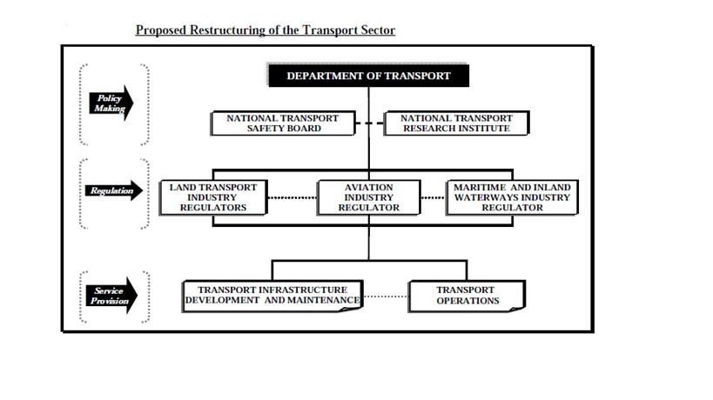

Source; *Republic of Kenya (2010), sessional paper on: integrated national transport policy, Government Printers, Nairobi. Page 29.*

The policy requires that the national government to establish transport department under the ministry of transport which will;

1. integrate and coordinate planning
2. improve and manage transport infrastructures
3. ensuring extensive research and the development of human resource
4. Ensuring that the transport policy is managed and developed well so that good standards for delivering transport needs is achieved.

The county governments are required to play the following functions in transport

1. Ensuring proper maintenance of county roads
2. Regulating traffic and providing adequate parking spaces within the transportation infrastructures
3. Maintaining public road transport and finally ferries and harbours

Institutional and legal framework for transport infrastructure is well spelt out. The policy requires the managing institutions of transport infrastructures like national government, county government, Kenya roads board, road agencies and other private partners shall encourage the following; the participation of stakeholders during development, maintenance and rehabilitation of transport infrastructures, to strengthen institutional and human capacities, to enhance good governance, to register road reserve and defending the road reserve from encroachment.

### THE 1973 NAIROBI METRO PLAN

From the review of the document on the Urban Growth and Sprawl of Nairobi, it is realized that the city of Nairobi has influenced the growth of some regions which are referred to us as the Satellite Centres. These centres include limuru, kiambu kikuyu and karuri to the northern side; kiserian, Ngong and ongata rongai to the west; Athi river, kitengela and machakos to the southern side and lastly ruiru, thika, tala and kangundo to the eastern side. These satellite centres have experienced rapid growth in various land uses giving and alarm to proper planning. The map below shows the Nairobi metropolitan region.

Map 5: Nairobi metropolitan map

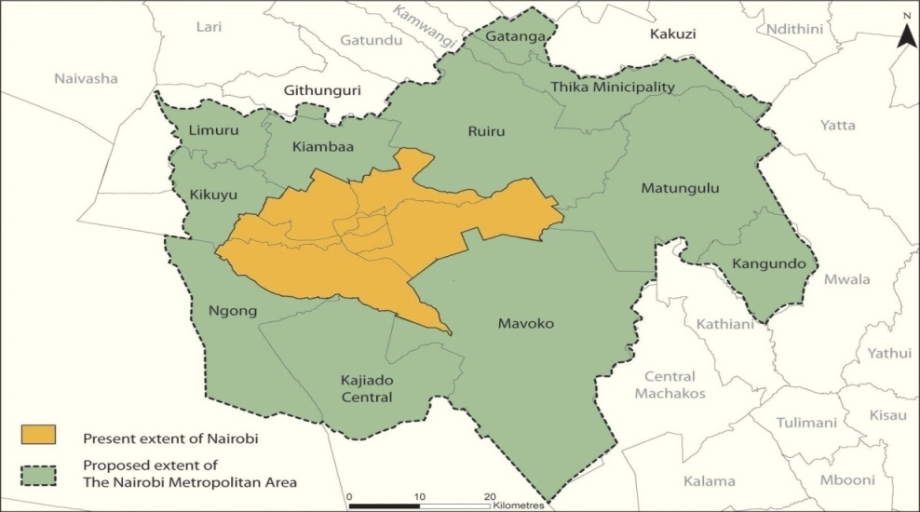

Source; [https://www.google.com](https://www.google.com/search?q=nairobi+metropolitan&rlz)

Initially the city of Nairobi had a strategic policy that was contained in the Nairobi master plan of 1948 then the Nairobi Metropolitan Growth Strategy of the year 1973 was established to provide the development framework of Nairobi and its satellite centres.

The 1973 Nairobi Metropolitan Growth Strategy was supposed to cover a period from 1973-2000. This development plan was also to direct the development of surrounding centers that are next to Nairobi such as Ngong town and others. The plan was to address issues such as transportation economic activities, land use, housing sectors, expenditure and revenue.

### THE NAIROBI METRO 2030 STRATEGY

The Nairobi metro 2030 strategy was also developed in the year 2008 in line with the Kenya vision 2030.This development strategy was to ensure that regions which are covered under the Nairobi metropolitan, experience effective growth as the Nairobi County also grows. Ngong town is under the Nairobi metropolitan. The area will benefit majorly in development of industries, commercial centres where industrial products will be marketed, better provision of infrastructure and services

## LEGAL FRAMEWORK

### THE CONSTITUTION OF KENYA (2010)

The constitution is the supreme document on the land that every Kenyan is mandated to follow its articles. The Constitution provides a framework on land use planning through productivity, equitability, efficiency and sustainability, Article 60(1). The State is provided with the power to regulate the land uses or any interest on or over land as stated in Article 66, for this purpose land use planning, public safety, public health, security, public order and public morality can be achieved in the development of Ngong town. The Constitution requires that environmental preservation and conservation in Article 70 is put in place.

### URBAN AREAS AND CITIES ACT

Urban areas and cities act provides a guideline for integrated development planning for cities, municipalities. The act is used as a basis for providing both physical and social infrastructure and even transportation. The act requires that every cities or urban areas needs to prepare an integrated urban development plans in accordance of third schedule of the act. On the third schedule, the following are outlined

1. An assessment of the current social, cultural, economic and environmental situation in its area of jurisdiction.
2. A determination of community needs and aligning them to the requirements of the Constitution.
3. Protection and promotion of the interests and rights of minorities and marginalized groups and communities.
4. A shared vision for its development and that of the county as a whole.
5. An audit of available resources, skills and capacities.
6. Prioritization of the identified needs in order of urgency and long-term importance.

### COUNTY GOVERNMENT ACT (2011)

The county government act was established by parliament to give effect to Chapter Eleven of the Kenyan Constitution which was promalgated in the year 2010. Chapter eleven of the constitution gives every county government an opportunity to execute powers, functions and responsibilities to deliver services. The purpose of county government is to plan and integrate economic, physical, social, environmental and spatial planning. County governments, cities and urban areas, sub-counties and Wards are recognized as the county planning authorities. The act provides a framework for county government on how to plan. The following are some of the principles of planning and development facilitation which are outlined in the act. The act requires that every county government shall;

1. Integrate national values in all processes and concepts
2. Protect the right to self-fulfillment within the county communities and with responsibility to future generations
3. Protect and integrate rights and interest of minorities and marginalized groups and communities
4. Protect and develop natural resources in a manner that aligns national and county governments policies
5. Align county financial and institutional resources to agreed policy objectives and programmes
6. effective resource mobilization for sustainable development
7. Promote the pursuit of equity in resource allocation within the county
8. Provide a platform for unifying planning, budgeting, financing, programme implementation and performance review
9. Serve as a basis for engagement between county government and the citizenry, other stakeholders and interest groups.

The act also outlines some of the Objectives for county planning.

1. Ensure harmony between national, county and Sub-county spatial planning requirements
2. Facilitate the development of a well-balanced system of settlements and ensure productive use of scarce land, water and other resources for economic, social, ecological and other functions across a county
3. Harmonize the development of county communication system, infrastructure and related services
4. Develop urban and rural areas as integrated areas of economic and social activity
5. Provide the preconditions for integrating underdeveloped and marginalized areas to bring them to the level generally enjoyed by the rest of the county
6. Develop the human resource capacity of the county.

The following are some of the mandates of county planning board

* 1. Coordinating integrated development planning within the county
  2. Ensuring integrated planning within the county
  3. Ensuring linkages between county plans and the national planning framework
  4. Ensuring meaningful engagement of citizens in the planning process;

The county government act requires that every county shall prepare the following types of plans which will be the framework for development;

* 1. **County integrated development plan**- this is a five year plan. The plan can recognize an institution which will be responsible for implementation and addressing the internal transformation of the county.
  2. **County sectoral plans**- this is a ten year plan which contains Programmes, a framework for budgeting and performance management and finally the plan it is to be reviewed every five years and updated every year. The county executive is the one responsible for reviewing and it is approved by the county assembly.
  3. **County spatial plan**- this is a plan which is produced every ten years by county governments. It is one of the component of CIDP which provides a spatial representation of socio-economic and infrastructure development programme.
  4. **Cities and urban areas plans as provided for under the Urban Areas and Cities Act**- The development of cities or municipalities relies on the success of City or municipal plans. The plan provides the principles and the role of land use and building plans, location of infrastructural facilities and the application of its development controls.

### PHYSICAL PLANNING ACT (1996)

The physical planning act is majorly concerned with the developments on land. The act provides laws which can guide and regularize developments. The current developments that are taking place in Ngong town are majorly residential, commercial and other minor land uses. The developers do not take into consideration the guideline of physical planning act hence resulting to continuing increase in informality.

### ENVIRONMENTAL MANAGEMENT AND COORDINATION ACT (1999)

Environmental Management and Co-ordination Act was established in the year 1999 by parliament so as to provide legal and institutional framework that will guide the management of environment. Environmental impact assessment it determines the potential impact a project can have on the environment and facilitates the better way on how environment can be protected and conserved through environmental planning so as to enhance sustainability. The act will be used as a basis guideline for managing and maintaining the environment during the whole period for the construction of the Ngong bus terminus.

### PHYSICAL PLANNING HANDBOOK

This is a document which was established and it contains rules and regulations and planning standards. The document seeks to establish complete land use planning guidelines and standards and considering emerging issues. The document outlines the process of preparation of the plan that is required from the initial stages up to the last stage. The schematic diagram below shows the guide in preparing a plan.

Figure 2: conceptual guide to plan preparation

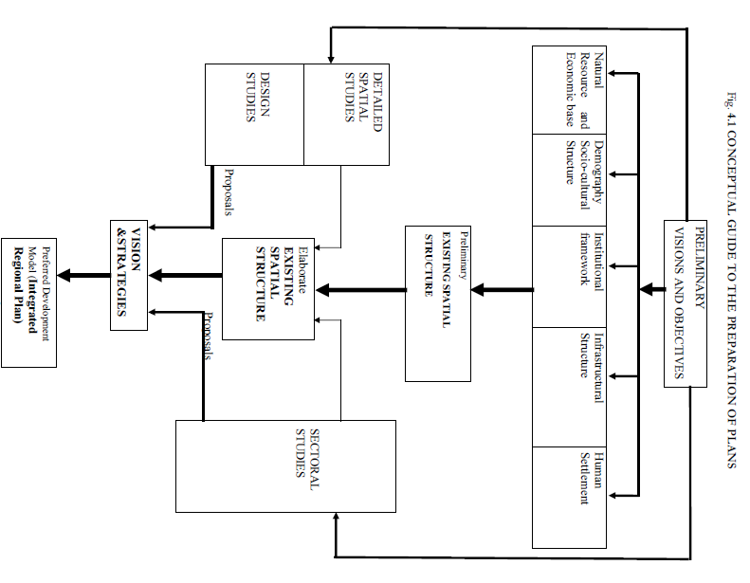

Source; *Republic of Kenya (2007), ministry of lands; physical planning handbook*

## REGULATORY FRAMEWORK, GUIDELINES, PLANNING AND DESIGN STANDARDS

**Planning guidelines and design standards**

These are guidelines that will facilitate the construction of the bus terminus.

**Accessibility of the bus terminus**

Bus terminus should be located in areas where it can serve adequate catchment population. The location of the bus terminus should consider the factors of concentration of human settlement, activities and various land uses and to ensure the distance of 400 metres or a 5 minutes is maintained. The figure below shows the population catchment of a well centralized bus terminus.

Figure 3: center aligned bus terminus

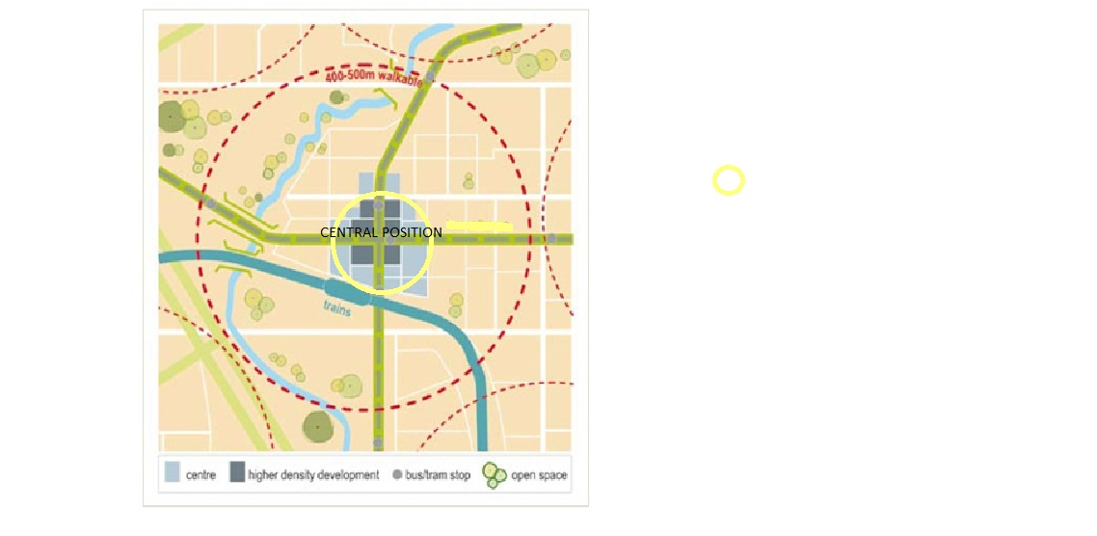

Source; Department of Transport [www.transport.vic.gov.au](http://www.transport.vic.gov.au) (2008), Public Transport Guidelines for Land Use and Development

**Turning positions**

The turning angle of a rear wheel of the bus should cover a radius of 14 metres from the departure parking platform towards the direction of the travel

**Curbs/bus bulb/nubs**

They are sidewalk extensions that are located along the parking lanes. The curbs have to be 6-8 inches high so that passengers may find it easy to alight and board. These extensions provide space for the other facilities like bus shelters and benches. The curbs minimize pedestrian crossing and ideally they should be located in areas where there is high pedestrian movements. The diagram below shows a curb.

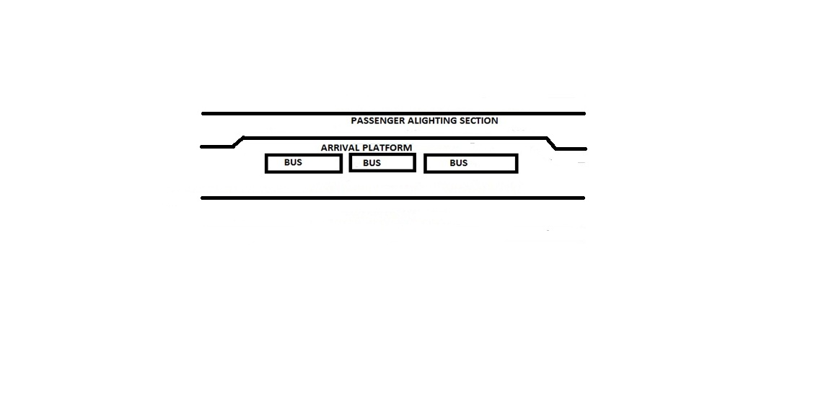Source; Webteam (2008), design manual. *A manual for coordinating public transit and land Use in greater bakersfield*

**Significance of the curb**

1. They enhance access to the arrival platform in the bus terminus
2. Designing the curb is easy and not really expensive

**Disadvantages of curbs**

1. At the arrival platform, the curb may cause public transport vehicles to queue hence beginning to cause congestion.

When calculating the loading area capacity of the vehicle, the following formula is used

**Capacity**= $\frac{\% of hour when buses are able toenter or leave the terminus}{time an average bus occupies the loading area+an allowance for unsually long dwells}$

**Bus shelter facilities**

Bus shelters are safety facilities which enable the passengers to protect themselves from weather conditions of the day and seating. They sometimes act as passenger waiting areas. When designing a passenger shelter facility, the following guidelines should be followed

* The shelter should have a dimension of 2.7 meters long by 1.5 meters wide.
* The shelter should have transparent sides to enhance security and accessibility.
* It should be provided with seating of a height 17 inches because higher seats are not comfortable.
* It is important to provide grab handles at the seats to enhance support.

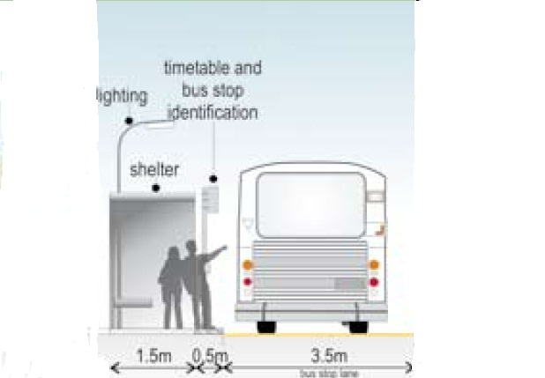

Source; Department of Transport [www.transport.vic.gov.au](http://www.transport.vic.gov.au) (2008), Public Transport Guidelines for Land Use and Development

**Seating**

Seating-Bus stop sitting is critical to maintaining pedestrian and passenger safety and convenience, as well as ensuring ease of bus vehicle access and operation

It should be provided with seating of a height 17 inches because higher seats are not comfortable.

**Lighting system**

The lighting system facilities provide adequate light at the bus terminus. When the lighting system is well installed, it can promote a sense of comfort to passengers who use the terminus during the late hours and it also enhances security.

**Sanitation facilities**

It is desirable to provide sanitation facilities at the bus terminus like toilet facilities (staff toilet facilities and passenger toilet facilities) to promote conveniences the users. It is mandatory for the local authorities to provide sanitation facilities especially where the public facilities are located.

**Trash Receptacle**

They facilitate cleanness. They are supposed to be located closer to bus shelter facilities so that they will enable the passengers to dispose the waste correctly.

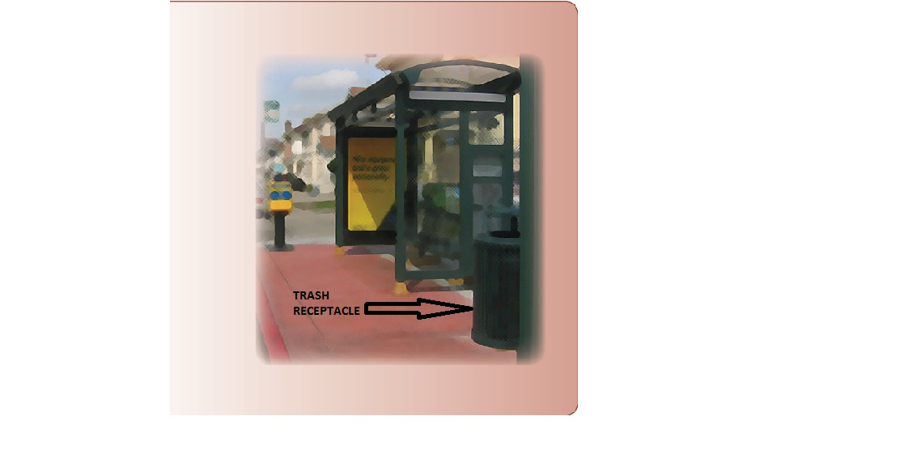

Source; Easter Seals Project Action, Toolkit for the Assessment of Bus Stop Accessibility and Safety, 2006

**Passenger information display**

Passenger information display is one of the important elements in a bus terminus. It conveys the updated schedule information and bus routes maps of various public transport vehicles. Passenger information display can assist the passengers to understand well the time and routes they want to take. The diagram below shows one of the facilities that provide passenger information.

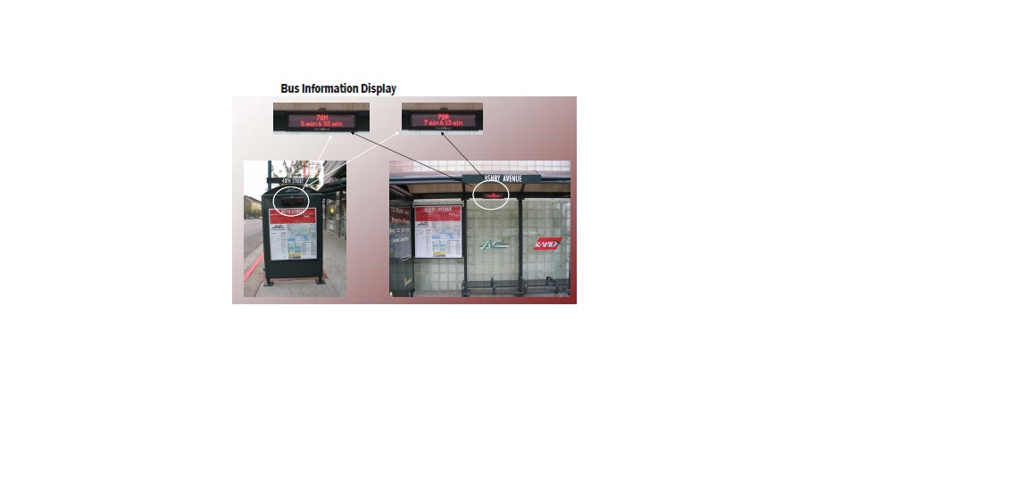

Source; Easter Seals Project Action, Toolkit for the Assessment of Bus Stop Accessibility and Safety, 2006

Figure 4: features of bus environment

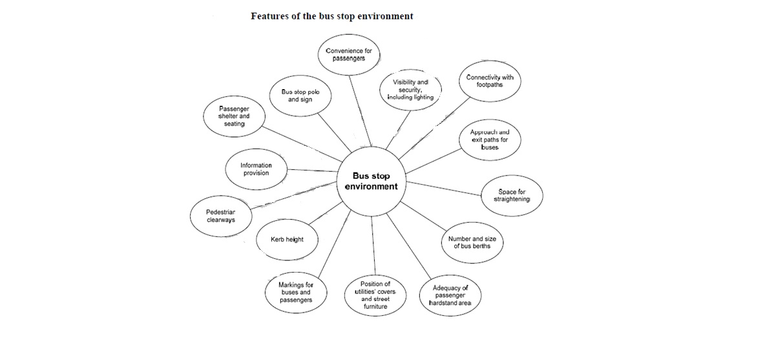

Source; Vwhe (April 2010) Bus Stop Guidelines *adopted from transport of London 2006*

## CASE STUDY

**Baramunda bus terminus in India**

Baramunda bus terminus is a modern bus terminus which is constructed at baramunda, in the city of Bhubaneswar in India. The terminus is located on a site of 5.84ha of which the terminus takes 60% of the land which is equivalent to 3.50 ha. The other 40% is designated for commercial purpose. During construction, the entry and exit points of the terminus were maintained because of reducing the macro level city traffic patterns of Bhubaneswar. The terminus is linked with curvilinear road and both entry and exit points are connected to the road. The terminus took duration of two years to be completed. The terminus is installed with modern facilities such as retiring rooms for transporters, air conditioned waiting hall, adequate boarding bays , alighting bays, food courts, kiosks, e-ticketing system, cloak rooms and also idle parking bays are provided. Landscaping has been done around the bus terminus. The diagram below shows the location and aerial view of baramunda bus terminus.

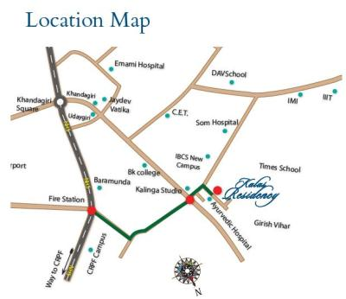

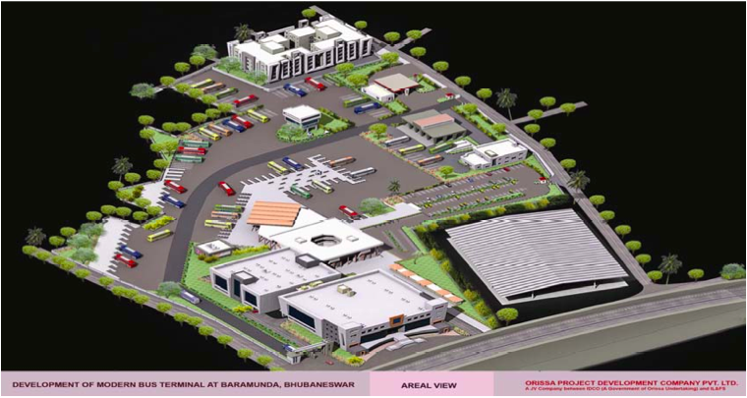

Source:<https://www.google.com/search?q=baramunda+bus+terminus&tbm=isch&tbo=u&source=univ&sa=X&ei=Iy6MU4f9McbKOM2OgbgL&ved=0CDcQsAQ&biw=1366&b>

Initially before the construction of the modern terminus, baramunda was facing challenges of transportation especially over relying on road transport. Due to this over-reliance on one mode of transport and Population increase, there is a lot of pressure in transportation facilities and infrastructure. The demand for transportation is high, making the urban areas not to be able to reach the transportation needs of the public. The problems of traffic congestion, informal bus stops, rapid accidents, delays, noise pollution and air pollution are commonly experienced in its cities. The picture below shows how the terminus was initially before construction of new bus terminus.

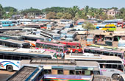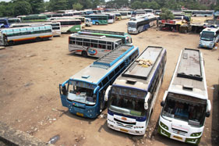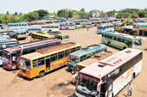

Source:<https://www.google.com/search?q=baramunda+bus+terminus&tbm=isch&tbo=u&source=univ&sa=X&ei=Iy6MU4f9McbKOM2OgbgL&ved=0CDcQsAQ&biw=1366&b>

India tried to establish the transport policy to improve urban transport which was in a great mess. The first policy was introduced in the year 1966 and the second was introduced in the year 1980. Unfortunately, both policies did not succeed to address urban transportation problems. The failure of these two policies was as a result of political interference. The national transport policy of the year 2006 was also established. This time round the policy tried to address the concerns. Bhubaneswar’s transportation demand had outstripped the carrying capacity of terminal facilities and roads. Congestion and delays are experienced in public bus terminal points and along its transport corridors. Parking spaces were also outgrown and the rate of vehicular growth is high. The travel demand for this city has increased rapidly and all these challenges resulted to the development of a modern bus terminus so as to minimize transportation challenges.

**Lessons learnt**

Reduced congestion- Construction of a modern bus terminus that address vehicular and non-vehicular needs and challenges as was evident after the construction of baramunda bus terminus minimized traffic congestion that was caused by public transport vehicle and it provided more parking spaces. There is free circulation of both public transport vehicles and private vehicles. More public transport vehicles were accommodated due to availability of sufficient parking spaces. Passenger safety and comfort is also enhanced.

Improved land use planning- especially within the sites where mixed use development exists provides rationalized land use such as shopping mall, improved and spacious market areas residential apartments and hospital facilities around the bus terminus.

Improved urban aesthetic through landscaping of the terminus can improved the site so that the site has a green belt that is running adjacent to the curvilinear road creating visual appeal.

* 1. **CONCEPTUAL FRAMEWORK**

County government act- requires that every county should provide quality and standard transportation facilities and infrastructure.

Integrated transport policy- aims to make Kenya a transport hub by ensuring elements of quality, standard, accessibility, linkages are put into consideration. The development of transport infrastructures and facilities are aimed to attain the expectations of the Kenyan vision 2030.

Integrated transport system that address the needs of stakeholders that is efficient, convenient and enhance enjoyment of clean environment

Kenya Vision 2030 addresses how A sustainable 50 year integrated national transport plan can be achieved through expansion of transport infrastructures, linkages, transport corridors and terminal facilities.

Policy guide

Legal guide

Sustainable bus terminus

Effective land use planning due to enforcement of by laws

Provisions of guidelines, regulations, and planning standards on land use planning (physical planning handbook, 2007)

Constitution of Kenya 2010-The Constitution provides a framework on land use planning through productivity, equitability, efficiency and sustainability, Article 60(1).

The Nairobi metro 2030 strategy- This development strategy is to ensure that regions which are covered under the Nairobi metropolitan, develops better transportation and infrastructure facilities.

Urban areas and cities act- act is used as a basis for providing both physical and social infrastructure. The act requires that every cities or urban areas needs to prepare an integrated urban development plans in accordance of third schedule of the act.

Generation of more revenue

Minimization of travel time

Reduction in congestion of public transport vehicles

Adequate parking spaces

## 

# CHAPTER THREE

# SITUATIOANAL ANALYSIS

## OVERVIEW

The chapter outlines an information on the physical location of the site at Regional Context, Sub-regional context, Local Context and Neighbourhood. It also gives the historical background context, topographical and natural environment characteristics, population and demographic characteristics, land use analysis and finally the institutional, legal, and financial issues of the project area.

## THE LOCATION CONTEXT OF THE PROJECT AREA

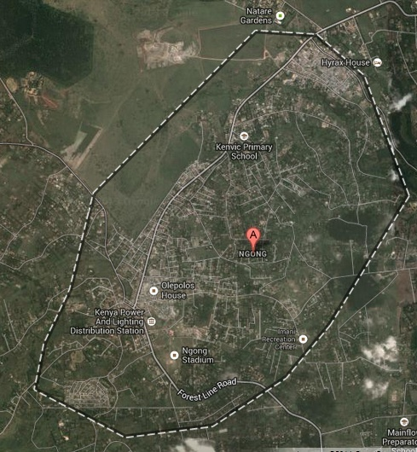The project area is located a section within the town centre of Ngong town in Kajiado county. The site is in the south west of Nairobi Kenya It lies along the great rift valley within the coordinates of 1°22′S 36°38′E with an elevation of 1,961 meters in altitude. The maps below shows the physical location of the site at Regional context, Sub-regional context, Local Context and eventually the Neighbourhood

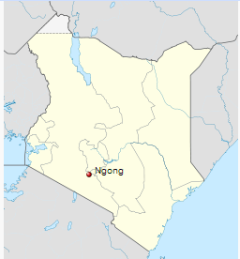

Source; Google earth, Satellite imagery of Ngong town

Source; Google images, map of Kenya

Map 6: site at national context

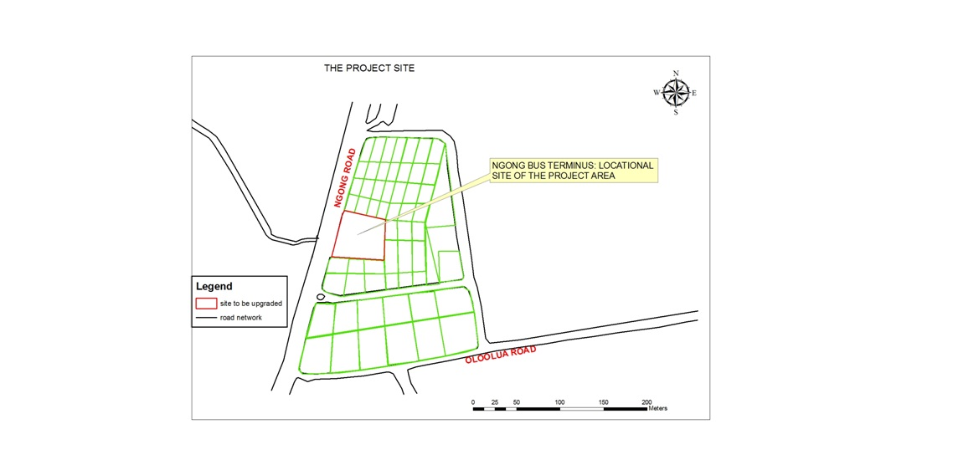

Map 7: site at neighborhood context

Map 8: site at local context

Source; author 2014

## BACKGROUND OF THE PROJECT AREA AND ITS HISTORICAL CONTEXT

During the early years, the area was predominantly occupied by the Maasai people. The word *"Ngong"* is generally a [Maasai](http://en.wikipedia.org/wiki/Maasai_language) word meaning "knuckles", because of the six hill peaks of the ridge, which basically stands alone rising from the plains around the Nairobi region. The area is endowed with various natural resources including soils, diverse vegetation and different species of wild animals among others.

## SITE ANALYSIS:

### TOPOGRAPHY AND NATURAL ENVIRONMENT CHARACTERISTICS

Ngong town lies within Athi Kapiti plains. The plains are characterized with gently undulating slopes and high hills especially towards Ngong which forms Ngong hills. Ngong hills are the catchment area for Athi River. Mbagathi river and kiserian tributaries drains there water to Athi river ( Source; <http://www.african-horizons.com>). The region around the project areas is endowed with natural resources like, Ngong hills, forests, rivers, and wildlife. Apart from the natural resources, the altitude and strategic position of the hills in relation to its surrounding region is of an economic value. The Ngong hills are peaks in a ridge along the [Great Rift Valley](http://en.wikipedia.org/wiki/Kenyan_Rift_Valley), located southwest near [Nairobi](http://en.wikipedia.org/wiki/Nairobi), in southern [Kenya](http://en.wikipedia.org/wiki/Kenya).

Map 9: topographical map of Ngong town

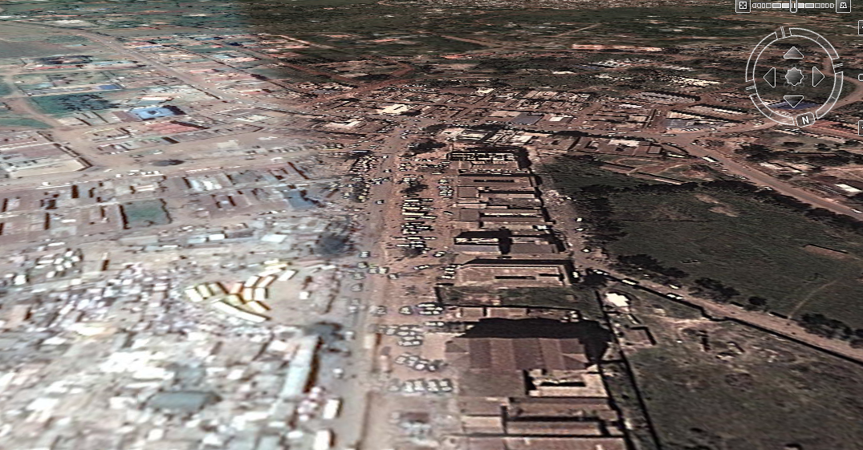

The landscape gets relatively flat as you move from Ngong town towards karen

Ngong bus terminus

Higher grounds due to Ngong hills

Source; Google earth map

### GEOLOGY AND SOILS

The project area is composed of both the basement system rocks, which are commonly of sedimentary and volcanic origin. In Ngong, where the Ngong hills are located, is primarily made up of volcanic rocks. Most of the geologic activities occurring in the Ngong hills, right from its formation, have been of a volcanic nature which have consequently resulted in the area being predominantly composed of volcanic rocks formed from volcanic ash, solidified basaltic lava and other pyroclastic materials which sedimented together into rocks.

Map 10: geological map of Ngong region



*Source African Journal of Science and Technology (AJST)*

*Science and Engineering Series Vol. 6, No. 1, pp. 105 – 115*

## SOILS

The geology around the project area is characterized by four main categories of soils.

**Ferralochromic soils/orthic lurisols**

These are dark red to strong brown sandy clay loam to clay soils. They are moderately deep to deep well drained moderately fertile soils and are usually developed from undifferentiated basement system rocks. These soils are suitable for construction of transportation infrastructures especially in areas where are found.

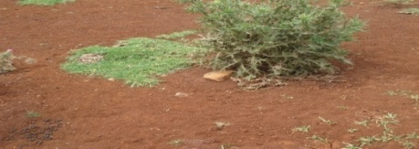 Plate 2: Ferralochromic soils

Source; field survey 2012

**Ferralic lurisols**

Are dusky red to dark brown sandy clay loam to clay soils. they are moderately deep to very deep well drained moderately fertile soils. They are developed from undifferentiated basement system rocks with volcanic ash mixture.

 Plate 3: Ferralic lurisols

Source; field survey 2012

**Mollic andosols**

They are black gravelly loams soils with humic top soils. They are developed on volcanic ashes and other pyroclastic material of recent volcanic activity. They are usually moderately deep to deep well drained friable and smeary soils of high fertility.

Plate 4: Mollic andosols soils



Source; field survey 2012

**Orthic rendzinas**

Are dark grey stony clay soils moderately calcareous soils. They develop from limestone rocks and calcitic mudstones. They are shallow, extremely drained, moderately fertile soils.

Plate 5: orthic rendzinas

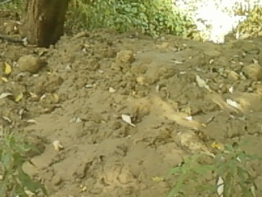

Source; field survey 2012

### RAINFAL

The rainfall pattern in all of the project area and entire Ngong region has a bimodal distribution with two major rainy seasons. The short rains fall between mid-October and mid-December while the long rains fall between March and May. Ngong region has a mean annual rainfall of 1000-800mm. the bus terminus is not paved and this becomes a problem during circulation of vehicles and passengers. The drainage system of the terminus needs to be improved.

### RIVERS

The Ngong Hills Forest Reserve is a source of some of the tributaries of Athi River. The Ngong Hills Area is categorized as an ASAL (Arid and Semi-Arid Lands) region and currently has no permanent rivers running through it. Ngong hills area in the past years had been characterized by numerous rivers which due to poor maintenance and human activities led to them drying up. Currently there are two major perennial rivers draining through the area, that is, Kiserian and Ngong Rivers. Seasonal streams include Kandizi and Nol Chora.

### TEMPERATURE

Temperatures in Kajiado District vary with latitude. They range from a mean maximum of about 30 degrees centigrade around Lake Magadi, to a mean minimum of 16 degree centigrade.

### WINDS

The direction of the prevailing winds is westerly. Ngong area experiences strong consistent high speed winds thought the day. The wind is used to turn wind masts that generate electricity. The masts are located in Ngong hills.

Map 11: map showing wind path within the site

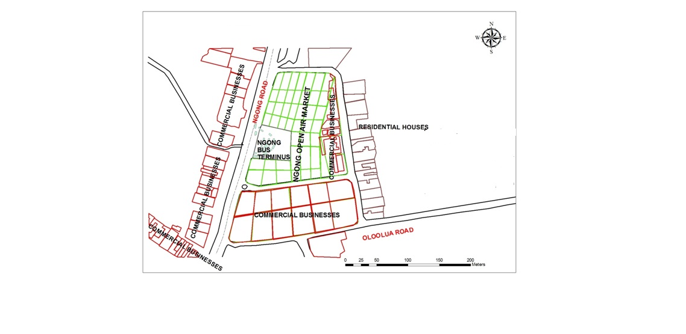

wind paths

WIND PATH OF THE PROJECT AREA

Source; author 2014

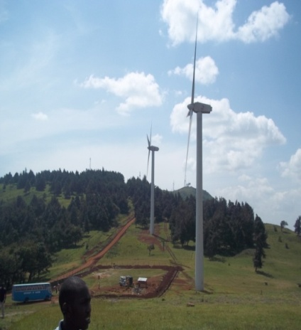

High presence of strong prevailing winds turning the wind masts for generation of electricity

Source; *field survey 2012*

Plate 6: wind mask

### SUN AND WIND PATHS

The orientation of the bus terminus is directly at right angles to the sun path making the angle of the solar incidence to be 00 . This makes the terminus to experience high solar temperatures during the day.

Map 12: sun path of the project area



Sun paths

SUN PATH AND INSOLATION OF THE PROJECT AREA

Source; author 2014

**Plate 7: the angle of the solar incidence of the site**

Source; <http://wiki.naturalfrrequency.com/wiki/solar> incidence

### VEGETATION

The project area is located close to the Ngong hill forest reserve. The Ngong Hill Forest Reserve is an indigenous forest with vegetation varying from grass, shrubs and trees. There is also variation in the distribution of the vegetation with increase in altitude. Most of the vegetation in the forest is natural even though there are patches where there is planted vegetation.

Plate 8: Ngong hills forest reserve

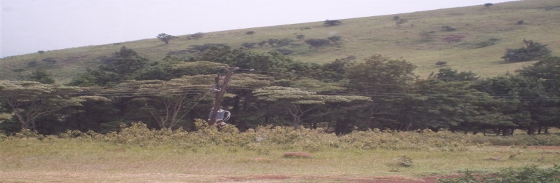

Source; *field survey 2012, Ngong hills forest reserve*

## POPULATION AND DEMOGRAPHIC CHARACTERISTICS OF THE PROJECT AREA

### POPULATION CHARACTERISTICS

The entire project area accommodates a total population of 18,091people and 5779 households. The total number of male is 8910 and female is 9181. The population density of this area is 2121 per square kilometer. This population represents the population within Ngong Township. The project area is found at the central position of Ngong town in Ngong division in Kajiado County. Kajiado County has a population growth rate of 5.5% (source; <http://www.kajiadocountygovernment.com>). The table below summarizes the demographic characteristics of the project area according to the Kenya national housing and population census report of the year 2009.

### SOCIAL ECONOMIC CHARACTERISTICS

The project area is the centre for attraction due to its centrality position in ngong town and is mostly occupied by the low income earners and the middle income earners. Due to rapid population growth and urbanization from both natural increase and high rates of migration, the project area creates an opportunity to carry out various economic activities that sustains their day to day life. The low income earners can averagely get Ksh 2000 to Ksh 4000 per month and the middle income earners can get Ksh 10000 to Ksh 25000 per month. The project area is occupied with both formal and informal business activities which are basically operated at the small scale level. A lot of people have faced a challenge in getting employment opportunities at the formal economic sector due to their limited education ability and inadequate working skills in the formal economic sector forcing them to fashion out their living in small scale business activities and informal business activities. The major small scale business activities are done at Ngong town open air market.

The informal business like hawking activities is very common in the sense that the hawkers sell a variety of products households utensils, fruits, cooked foods, other food stuffs, imported used clothes, electronic gadgets like phones, footwear, traditional artefacts like those of Maasai products and lastly jewelries. Other hawkers have set up unauthorized structures where they operate their business from. Other activities like light service industries such as garage services are also evident. Some people are operating tuk tuk and boda boda motor cycle to earn their living. It is evident that majority of informal activities are conducted in areas where there is high concentration of people and for this reason, customers can easily access goods. The informal business activities have taken up the spaces that were provided for public transport vehicle leading to problems of inadequate parking spaces hence the creation of informal bus terminus.

### CULTURAL AND POLITICAL PROFILE OF THE POPULATION

Previously the area was occupied by the Maasai inhabitants. After some years, other tribes begun to occupy the area by purchasing the land and residing there. Others come to settle temporarily and others came for the reasons of employment purposes. The project area is currently under the cosmopolitan of Ngong region which is within Nairobi metropolitan region.

## INSTITUTIONAL FRAMEWORK

Ngong town is under the county government of Kajiado. Kajiado county government is the leading institution that governs any development within it is boundaries. Any development provisions in county governments are outlined and guided with the requirements of urban areas and cities act of 2011, physical planning act and county government act. In reference to the development of site, the physical planning act considers it as a part development plan because it defines it as a ***precise site for immediate implementation of specific projects or for alienation purposes*** (Source; physical planning act, cap 286). The funding of the project site mainly relies on the county government. According to urban areas and cities act of the year 2010 and county government act requires that the county governments to should provide effective and efficient transportation infrastructural facilities and services. Other supportive institutions are; community based organization of the people of Ngong and private sectors.

National Environmental Management authority will be responsible for providing legal and institutional framework that will guide the management of environment through the use of the guidelines that are outlined in environmental management and Co-ordination Act (EMCA) (1999). Environmental impact assessment it will determines the potential impact a project which can create on the environment. The act will be used as a basis guideline for managing, protecting, conserving and maintaining the environment during the whole process for the construction of the Ngong bus terminus.

## LAND USE ANALYSIS

Map 13: land use analysis map of the site

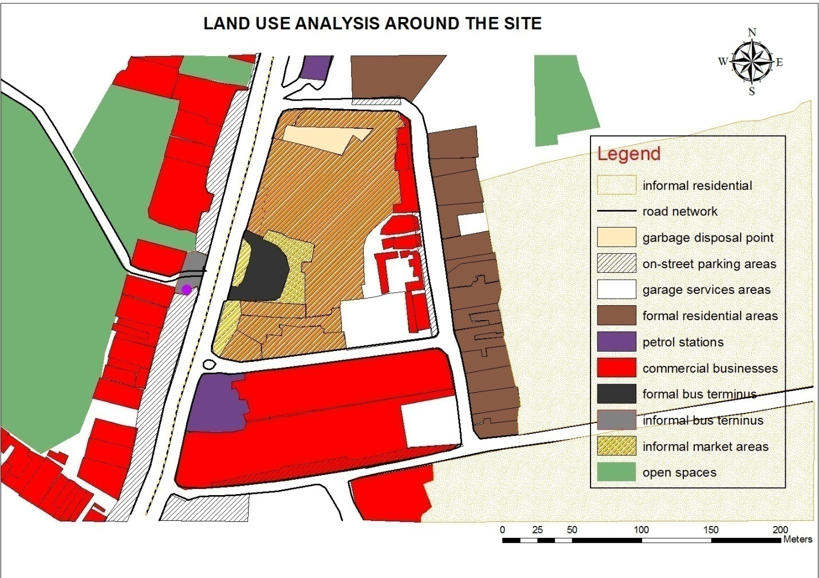

Source; adopted form Google image by the author 2014

**RESIDENTIAL LAND USE**

Residential land use is the most dominant land use in Ngong. It has middle income earners, low income earners and very few high income earners group. The region is occupied with formal and informal residential land use. Mixed use residential developments are also taking shape. This is seen because the buildings are constructed in such that the ground floors are occupied with commercial activities and other upper floors are designated for residential use. In Ngong town the housing density is growing at a faster rate. This increase in housing density attracts more provision of services, goods and public transport system. The operation of public service vehicles forms an industry that gives the service to large number of population hence it eventually forms the backbone of transportation system in Ngong town. Ngong being a cosmopolitan region, it is experiencing intensive development growth on land uses due to rapid increase in population. The new permanent high rise apartments are being erected to accommodate the middle class people. Houses are being constructed in modern styles that have attracted this level of income group. Some of these people have bought land and built their homes. Majority of the houses are constructed with rocks because the geological structure of Ngong contains mainly rocks. With few exceptions, other houses are built with bricks. The roofs are covered with iron sheets and others with tiles. The informal settlements are located near the town centre of Ngong. The building standards have not been considered completely. People live in houses that are constructed with iron sheets and the level of infrastructure facilities and services is poorly provided.

**ECONOMIC/COMMERCIAL LAND USE**

Ngong is served with an open air market where traders are selling their goods to consumers. The space used for market operation activities have been outgrown due to high demand of space use. Increase in numbers of the traders have encroached the spaces that are designated for parking at the bus terminus. There are also operation of activities such as small-scale commercial enterprises (small kiosks, hawking activities and informal eateries points), are situated along the road reserve and around the bus terminus. The hawkers sell variety of products such as cooked food, fruits, household utensils, electronic gadgets such as phones, imported used clothes, traditional artefacts, jewelry, footwear and etc. It is evident that majority of informal activities are conducted in areas where there is high concentration of people and for this reason, customers can easily access goods.

**SERVICE INDUSTRY LAND USE**

This kind of industry entails the provision and availability of garage services. More garage businesses have been opened up to service both public transport vehicles and private vehicles. Garage services are located around the project area.

**TRANSPORTATION LAND USE**

Ngong town is a hub for public transport due to development high residential densities. The transport system in Ngong town can be classified into; Road transport and Non-motorized transport. Road transport is the key and the most recognized mode of transport and the only means of transport in Ngong town. The town is connected with a two lane tarmac ked road. The road transport connects the residential areas, some of the education institutions and other minor land uses. Ngong town is connected with various classes of roads ranging from the main carriage way that comes from Nairobi toward kiserian and some access roads within the town. Majority of these roads are murram roads, earth roads and the only one tarmac road that comes from Nairobi town going towards kiserian. The available modes of transport include matatus (shared mini-bus taxis), buses, bodabodas (motorbikes), Tuk-tuks (three-wheeled taxis) and regular taxis.

It should be equally noted that the public transport infrastructural facilities are not adequately provided, as the levels of congestion capacities is increasing. This leads to unprecedented increase in the levels of traffic congestion along the major road and at terminal facilities. The tarmac ked road in Ngong town is narrow and therefore requires expansion. In regard, parking spaces are not provided, and this has encouraged park on the road reserves. The road reserve is poorly maintained and is majorly used by informal activities such as the hawkers sell variety of products such as cooked food, fruits, household utensils, electronic gadgets such as phones, imported used clothes, traditional artefacts, jewellrey, footwear and etc.

Non-motorized transport facilities are not provided well. They use the same carriage way the motor vehicles are using. The pedestrian walks and cycling lanes have not been provided since the pedestrians also use the road. The increase in population has led to the increase in public transport. This direct proportionate change is facilitated to satisfy the demands of the public. Majority of the people are non-car owners, hence they largely depend on public transport. Matatus are the most common form of public transport in Ngong town. Majority of these Matatus are privately owned and the most popular form of local transport. The current bus terminus cannot accommodate all the public transport vehicles which operate from Ngong town because the numbers of the matatu operators have increased. This has resulted to formation of informal bus terminus on the road reserve in a section within the CBD of Ngong town. This informal bus terminus is actually located opposite the existing bus terminus

# 

# CHAPTER FOUR

# PROJECT PLANNING DESIGN AND IMPLEMENTATION

## OVERVIEW

The aim of this chapter is to provide a framework for planning and design of the project, development of the spatial plan, site planning and development stages, detailed design formulation and development of detailed action plans, implementation strategies in respect to the objectives, programms, strategies of the project and finally the implementation schedule.

## PLANNING AND DESIGN OF THE PROJECT

Bus terminus has to be located in places where both passengers and vehicles can be able to access easily for the purpose of parking, board and alight safe and convenient. They need to be positioned in areas of particular need where they can be able to serve different activities. When locating a bus terminus, various factors are considered such as;

1. **Catchment area**

Bus terminus should be located in areas where it can serve adequate catchment population. The location of the bus terminus should consider the factors of concentration of human settlement, activities and various land uses and to ensure the distance of 400 metres or a 5 minutes is maintained. The figure below shows the population catchment of a well centralized bus terminus.



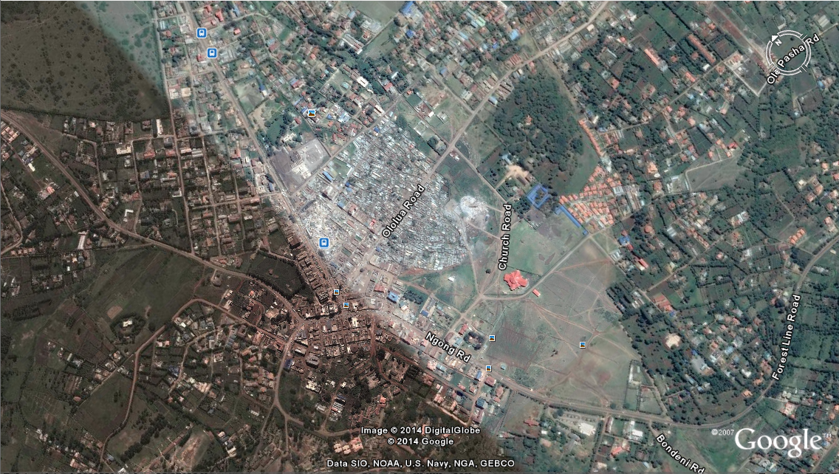

Figure 5: locating a bus terminus

Source; Department of Transport [www.transport.vic.gov.au](http://www.transport.vic.gov.au) (2008), Public Transport Guidelines for Land Use and Development

1. **Capacity factors**

Capacity factors can be seen in terms of vehicle capacity or person capacity. Vehicle capacity helps to determine the number of vehicles an area is served with and to see if the place is effective for the location of the bus terminus. Person capacity can also be regarded as the catchment population of an area as discussed above.

1. **The topography**

Locating the bus terminus one must consider the topography of an area. This is effective because other factors such as the design of the bus terminus, construction costs, locating infrastructure facilities and others.

1. **Security and safety**

Bus terminus should be located in areas where there is suitable security systems and safety. Passenger safety is crucial because it can enhance convenience to both passengers and operation of activities.

1. **Infrastructural facilities**

It is important to locate a Bus terminus where there are enough supporting infrastructural facilities. Infrastructural facilities can improve the efficiency and effectiveness of the bus terminus.

1. **Central accessibility**

Bus terminus should be located at the central place of an area. This is important because central areas are easily accessible and possibly a 400 metres walk or a 5 minutes walk can be managed.

1. **Road intersections**

Where there are more intersections of roads, locating a bus terminus can be easy. Areas with more intersections of roads are prone to location of numerous activities, high population catchment and more public transport vehicles.

1. **Legal requirements**

These are the guidelines that define the requirements for designing and locating the bus terminus.

1. **Demand generators**

Densification and concentration of human activities and other land uses require effective supply of transportation infrastructure and facilities. Bus terminus can be effectively located in busy areas to provide more transport services.

## EXPECTED OUTPUTS AND OUTCOMES OF THE DEVELOPMENT PROJECTS

Table 2: expected output and outcomes of the development project

|  |  |  |
| --- | --- | --- |
| PROJECT OBJECTIVES | EXPECTED PROJECT OUTPUT | EXPECTED PROJECT OUTCOMES |
| Re-organization of the land use structure within the bus terminus | An effective land use plan that will provide a basis for more development | A well coordinated land pattern |
| To develop an effective transport land use plan of the project area so that to enhance adequate provision of parking spaces for public transport vehicle. | Integration of transport planning and land use | Adequate parking spaces for public transport vehicles |
| To develop a basis for the redevelopment of the bus terminus through institutional implementation framework, monitoring and evaluation. | There will be Appropriate implementation schedule of the project. | An effective project implementation, monitoring and evaluation |

## DEVELOPMENT OF THE SPATIAL PLAN

After problem identification, formulation of goals and objective for the project, the following stages provided a framework for the development of the spatial plan.

Figure 6: development of the spatial plan

Problems identification and analysis

**Planning/ inception phase**

Project brief

Feasibility-if viable on economic, social, environmental

Environmental impact assessment

Risk assessment

**Design phase**

-Concept-formation of bubble diagrams

-Preliminary designs-looking at salient features

-Sketches

-Schematic designs

Synthesis

Source; author 2014

Figure 7: conceptual guide for plans preparation

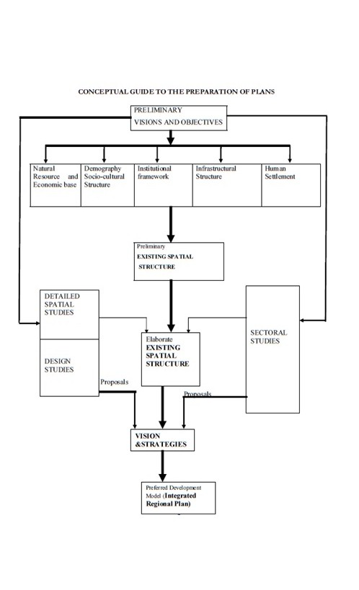

Source; adopted from Republic of Kenya (2007), ministry of lands; physical planning handbook

## DESIGN OF ALTERNATIVES

From the analysis of the present situation at the site, the following alternatives have been considered for the design of the site.

**Alternative one: Transport modal- Upgrading Ngong bus terminus**

The transport system within the study area needs to be re-planned and upgraded. Ngong bus terminus is well centralized and it serves effectively various land uses. The terminus needs to be upgraded considering its current situation. The upgrading can provide adequate parking spaces and improve the effectiveness and efficiency in service operation and the operation of activities around. During upgrading, other factors like passenger safety and convenience needs to be regarded as important aspects. Other supporting facilities and acceleration lane has to be designed so that the connection of the terminus to the road is properly developed to reduce the traffic congestion and the risks of accidents. The service lane will enable the public transport vehicles to enter and exit in an effective way. The main road that passes at the terminus has to be expanded to minimize effects of congestion and the pedestrian lane to be provided. The need to provide a service lane is important because it will reduce the problems of congestion and reduce the chances of accidents

**Alternative two: Relocating the informal bus terminus**

In contrast to the upgrading of the bus terminus, the urban space (road reserve at the town centre of Ngong) where public transport vehicles are operating from needs to be conserved and preserved. The relocation of the informal bus terminus requires the Land/space for development. Space is one of the most important factors in considering space use activities. Looking at the existing situation of Ngong town, there are a lot of developments and high concentration of activities which have outgrown the available spaces. The economic backbone of the town depends on the developments and activities that are being carried out on daily basis. These activities and developments are centralized and concentrated within the town centre. This makes the town to be more congested since it lacks more space for expansion. Relocating a bus terminus to an alternative space can help to reduce factors like congestion and its good for future expansion.

**Challenges of alternative two**

Looking at the cost benefit analysis, the relocation and construction of the new bus terminus requires large amounts of money to be funded. The cost of acquiring land and purchasing building materials and facilities is very expensive.

**Evaluation of the alternatives**

After considering both alternatives, the following criteria were used to identify the best option.

-Accessibility, Availability of space, efficiency, Topography, Availability of supporting infrastructure facilities, Cost minimization, Service coverage, Availability of transport corridors, Integration of various land uses, Catchment population coverage, Location of human activities

**Appraisal techniques**

On the basis of evaluating the two alternatives, the following was also considered; cost benefit analysis, goal achievement matrix and financial resource techniques.

**Cost benefit matrix**

Table 3: cost benefit matrix

|  |  |  |
| --- | --- | --- |
| **Alternative** | **Advantages** | **Disadvantages** |
| **Upgrading Ngong bus terminus** | -The terminus is well centralized within the town.  -The terminus is easily accessible  -It provides quick transportation services because is located adjacent to Ngong open air market and other existing developments.  -It is located near the main transport corridor which connects the town to other place.  -Fewer funds can be used to upgrade the site compared to construction of new site.  -The topography where is located is relatively flat hence it becomes easy for construction. | -There will be more and more concentration of activities which may result to informality.  -Being centralized within the town, it can cause more congestion because of its attraction. |
| **Relocating the informal bus terminus** | -It can attract new developments towards where is located.  -It can minimize congestion at the town centre if it will be located outside the town centre.  -more spaces can be acquired for development.  -reduce pressure between the public transport and the traders. | The cost of acquiring land for relocation and purchasing building materials and other facilities is very expensive |

**Source: author 2014**

**Goal achievement matrix**

In goal achievement matrix, the following values were used to represent goals; one and zero. The value of one represents any goal and the value of zero represents no achievement of the goal by an alternative scenario assuming the value of the goals have the same importance.

Table 4: goal achievement matrix

|  |  |  |  |  |  |  |  |  |
| --- | --- | --- | --- | --- | --- | --- | --- | --- |
| **ALTERNATIVES** | **GOALS** | | | | | | | **SCORE** |
|  | Accessibility | Cost minimization | Economical viability | Service provision | Availability of space for future expansion | Reduction in congestion | Efficiency |  |
| Upgrading Ngong bus terminus | 1 | 1 | 1 | 1 | 0 | 0 | 1 | 5 |
| Relocation of informal bus terminus | 0 | 0 | 1 | 0 | 1 | 1 |  | 3 |

Source: author 2014

**Financial resource technique**

This refers to amount of capital required for;

* Construction cost
* The cost of relocation
* The cost of upgrading
* Operation cost

From the matrix, it is noted that upgrading the bus terminus requires less cost to be incurred compared to relocation.

**The preferred alternative**

From the analysis of cost benefit analysis, goal achievement matrix and financial resource techniques, it noted that the upgrading of Ngong bus terminus is the best alternative for the project.

**Justification**

* it can be easily accessed because it is centrally placed
* It can improve and provide wide coverage of services to adjacent residential neighborhood, market and other land uses.
* it is economically viable
* it is directly connected with the main road (Ngong road)

## SITE PLANNING/DESIGN AND DEVELOPMENT PROCESS STAGES

**Problem identification and analysis**

The problem was identified in a research planning project under the topic of; implication of informal bus terminus on the road reserve. (section within the town centre of Ngong town). Under this topic, it was found that the current bus terminus cannot accommodate all the public transport vehicles which operate from Ngong town because the numbers of the matatu operators have out grown the spaces that are available. And this leads to the emergency of informal bus terminus along the road reserve. The points where informal matatu terminus is operating tend to cause problems such as congestion and interference with pedestrian movements. The site is located at the central position of the town and next to the Ngong open air market. It is centrality provides easy accessibility to various parts of the township. The analysis on physical characteristics in terms of geology, soil, topography, hydrology and drainage was also done so as to consider how development would commence. The map below shows a summary of the situation analysis of the project area.

Map 14: situational analysis map

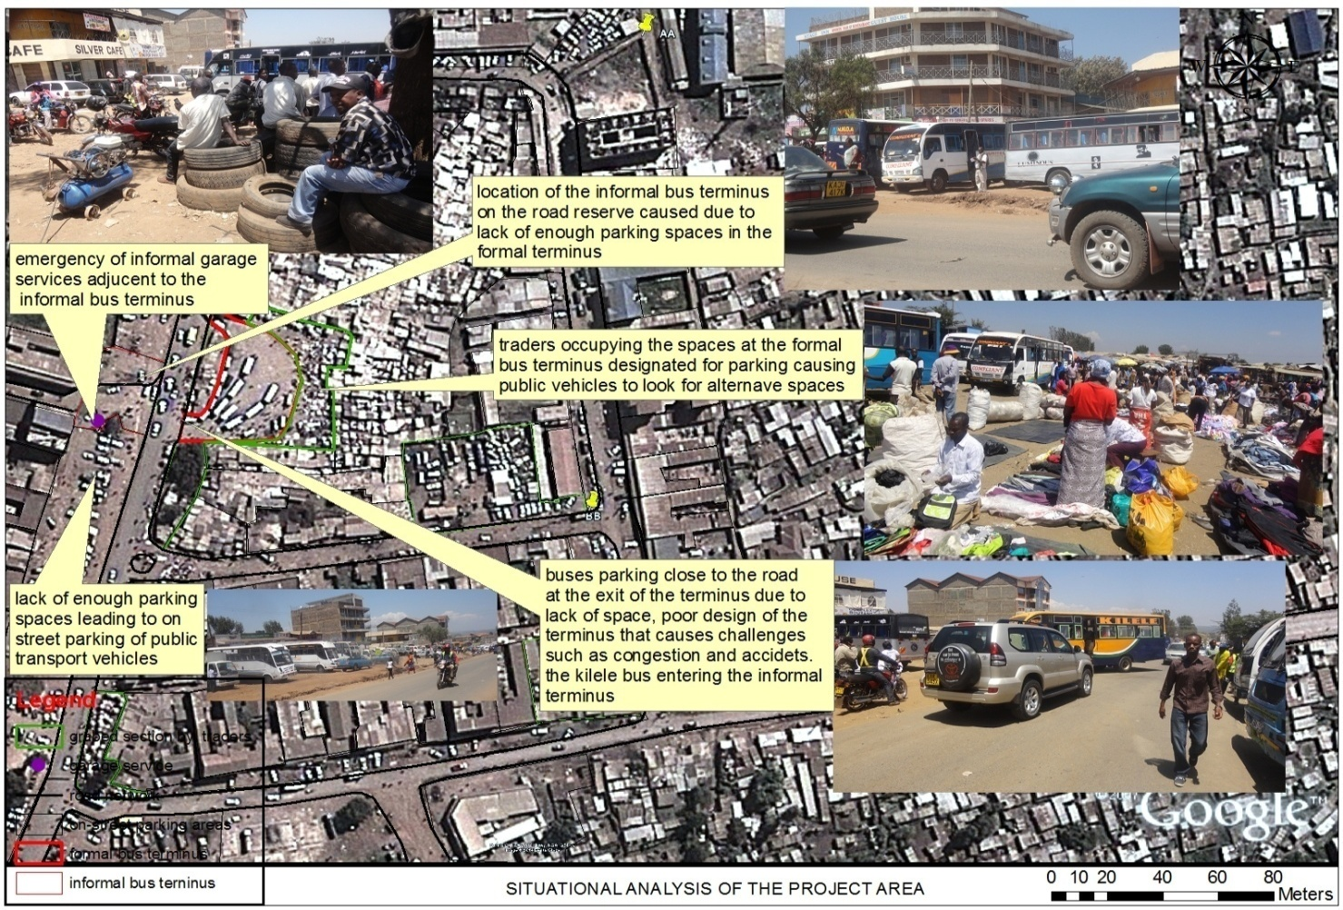

SITUATIONAL ANALYSIS

Source; adopted by author from Google image

From identifying the problem, the data was collected and analyzed according to the research questions.

**Formulation of goals and objectives**

At this stage, goals and objectives were formulated that will be used as a framework for designing a sustainable bus terminus. The goal of this project is to relocate and integrate the informal bus terminus to main bus terminus. The objective of the project is as follows;

1. To formulate a workable mechanism that will facilitate the re-organization of various land-uses around the bus terminus
2. To come up with proper designs of the proposed bus terminus that will be the basis for effective transport system
3. To provide a good framework for the implementation of the project through application of an effective monitoring and evaluation procedures

During the design of the bus terminus, the following elements must be considered

1. Bus shelters facilities- providing protection against weather conditions of the day and enhance passenger comfort
2. Small shops such as kiosks- to provide services, goods and maintain passenger convenience.
3. Litter bins- to enhance clean and aesthetic environment by enhancing proper disposal of waste products.
4. Seating-Bus stop sitting is critical to maintaining pedestrian and passenger safety and convenience, as well as ensuring ease of bus vehicle access and opera
5. Kerb-to enhance passenger movement and safety
6. Lighting systems- to facilitate effective security systems, safety and passenger comfort.
7. Parking bays-to allow bus parking during boarding of passengers.
8. Sanitation facilities such as toilets-to promote passenger comfort and convenience.
9. Information display facility-to facilitate the passenger to know the time, route and the kind of public vehicles serving at different routes

**Formulation of alternative proposal**

Formulation of alternative proposals assists one to have more alternatives. From our case, some alternatives will be formulated and assessed if they can satisfy the following criteria that will be used to identify the best proposal. –Accessibility, Availability of space, Topography, Availability of supporting infrastructure facilities, Cost minimization, Service coverage, Availability of transport corridors, Integration of various land uses, Catchment population coverage, Location of human activities

**Appraisal and preferred of alternative**

On the basis of evaluating the alternatives, the following will be considered to provide the preferred choice; cost benefit analysis, goal achievement matrix and financial resource techniques.

**Implementation of the preferred choice**

After the selection of the preferred alternative, the said alternative will be implemented as a proposed project for development.

**Monitoring and evaluation**

The monitoring of this project will begin immediately once the stages are set to handle various tasks. The environmental impact assessment will be carried out to value the impact the project has to the environment. The impact can be determined by looking the environmental aspects, social aspects and economical aspects. The evaluation of the project will be done under three phases. The first phase is the mid-term evaluation, terminal evaluation and lastly post implementation evaluation

Figure 8: planning process

**Schematic diagram for planning processes**

FORMULTION OF THE ALTERNATIVE PROPOSAL

PROBLEM INDENTIFICATION AND SYNTHESIS

GOALS AND OBJECTIVES

IMPLEMENTATION OF THE PREFERED CHOICE

MONITORING AND EVALUATION

APPRAISAL AND CHOICE PREFERED ALTERNATIVE

***Source: adopted from physical planning hand book 2007***

## DEVELOPMENT OF DETAILED ACTION PLAN

**Parking requirements**

When providing for parking spaces at the bus terminus, the following requirements should be considered as shown below.

* The turning angle of a rear wheel of the bus should cover a radius of 14 metres from the departure parking platform towards the direction of the travel.
* Each bus should have a parking width of 3.50 metres.

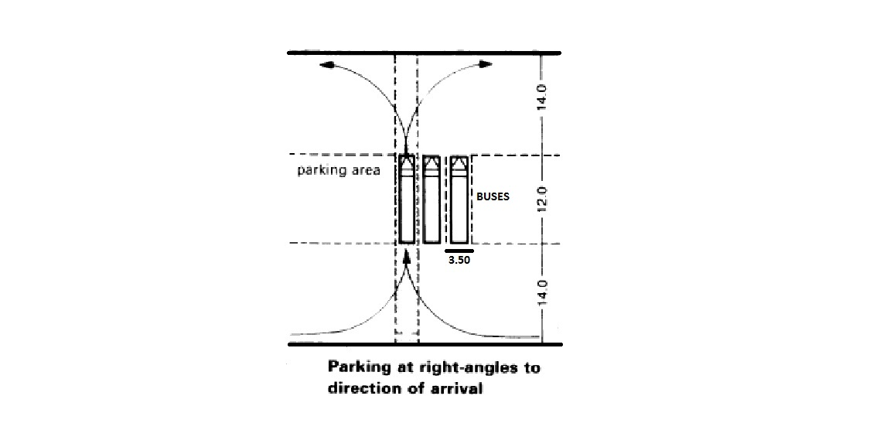

Source; adopted from Ernst and peter neufert (2001) architects data third edition page 431

**Bus shelter facilities**

Bus shelters are safety facilities which enable the passengers to protect themselves from weather conditions of the day and seating. They sometimes act as passenger waiting areas. When designing a passenger shelter facility, the following guidelines should be followed

* The shelter should have a dimension of 2.7 meters long by 1.5 meters wide.
* The shelter should have transparent sides to enhance security and accessibility.
* It should be provided with seating of a height 17 inches because higher seats are not comfortable.
* It is important to provide grab handles at the seats to enhance support.
* The shelter should provide cover from natural elements such as rainfall, high temperatures and dust.



Source; Department of Transport [www.transport.vic.gov.au](http://www.transport.vic.gov.au) (2008), Public Transport Guidelines for Land Use and Development

**Conceptual modal design**

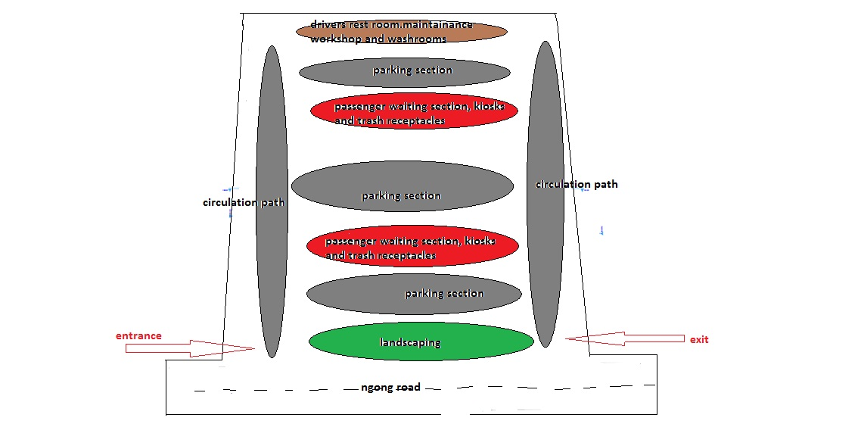

Source: adopted from Ernst and peter neufert (2001) architects data third edition page 431

**The site plan**

## POPULATION PROJECTION

Due to rapid population growth and urbanization from natural increase and high rates of migration, the population projection of Ngong town in five years can be determined through using the following formula.

$$P_{0}{\left(1+n\right)}^{r}=population projection$$

Where;

${ P}_{0}$ = the current population

n= the population growth rate

r= years of projection

$$18,091{\left(1+0.055\right)}^{5 years}=population projection$$

The table below shows the population projection trends from the year of 2014 to the year of 2030

The table below shows the population projection trends from the year of 2014 to the year of 2030

|  |  |  |  |  |  |
| --- | --- | --- | --- | --- | --- |
| **YEAR** | **2009** | **2014** | **2019** | **2024** | **2030** |
| **POPULATION PROJECTION TRENDS** | 18,091 | 23,644 | 30,902 | 40,388 | 52786 |

***Table 5; population projection table***

From the population projection table, the graph indicates the trends in population

Source: author 2014

## LAND BUDGET PROPOSAL

## 

|  |  |  |
| --- | --- | --- |
| **LAND-USE** | **PERCENTAGES** | **AREA OCCUPIED** |
| Waiting area | 6.5% | 300 $M^{2}$ |
| Parking spaces | 34.8% | 1600 $M^{2}$ |
| Circulation and landscaping elements | 45% | $${2067M}^{2}$$ |
| Small shops | 0.17% | $${8M}^{2}$$ |
| Departure platform/ Arrival platform | 10.87% | $${500M}^{2}$$ |
| Toilets and washrooms | 1.1% | $${50M}^{2}$$ |
| others | 1.6% | $${75M}^{2}$$ |
| **TOTAL SPACE** | **100%** | $${4600M}^{2}$$ |

## IMPLEMENTATION STRATEGIES

|  |  |  |  |  |  |
| --- | --- | --- | --- | --- | --- |
| PROJECT OBJECTIVES | TASK TO BE DONE | TIME FRAME | ACTORS | INDICATOR OF SUCCESS | INPUTS |
| To formulate a workable mechanism that will facilitate the re-organization of various land-uses around the bus terminus | Formulation of land use plans  Implementation of land use plans  Enforcement of land use plans | 3 YEARS | County government of Kajiado.  County Planning Unit of Kajiado.  Professional Consultants such as planners, Architects, engineers, Surveyors | Effective linkage of various land uses | Proper legislative framework  Regulatory framework  Human resource  Professional expertise |
| To come up with proper designs of the proposed bus terminus that will be the basis for effective transport system | Designing of plans for the proposed bus terminus.  Construction of the bus terminus | 3 YEARS | County Planning Unit of Kajiado.  Professional Consultants such as planners, Architects, engineers, Surveyors | Improvement of service delivery and identification of more parking spaces. | Professional expertise  Human resource  Financial resources  Standards, legislative and regulatory guidelines |
| To develop an integrated land use transport system that will be sustainable |  | 3 YEARS | County Planning Unit of Kajiado.  Ministry of roads and infrastructure.  Professional Consultants such as planners, Architects, engineers, Surveyors | Effective and efficient circulation of vehicles around the bus terminus  Compatibility and workable of land uses  Sustainable transport system within Ngong town | Professional expertise  Human resource  Financial resources  Standards, legislative and regulatory guidelines |
| To provide a good framework for the implementation of the project through application of an effective monitoring and evaluation procedures |  | 3 YEARS | County government of Kajiado.  Private sector.  Professional Consultants such as planners, Architects, engineers, Surveyors | A progressive and successful project | Standards, legislative and regulatory guidelines |

## IMPLEMENTATION SCHEDULE

The matrix below shows the implementation schedule of the project. The matrix has three phases, namely, short term, medium term and long term. Different tasks of the project will also be done at different quarters of the year.

|  |  |  |  |  |  |  |  |
| --- | --- | --- | --- | --- | --- | --- | --- |
|  |  | **SHORT TERM-2014** |  |  | **MEDIUM TERM-2015** |  |  |
|  |  | 0-4 months | 4-8 months | 8-12 months | 0-4 months | 4-8 months | 8-12 months |
| PHASE | ACTIVITY |  |  |  |  |  |  |
| Phase 1 | Site analysis | X |  |  |  |  |  |
| Phase 2 | Preparation of plans, designs and presentation of approval of plans and designs. | X |  |  |  |  |  |
| Phase 3 | Land/space restoration | X |  |  |  |  |  |
| Phase 4 | Environmental impact assessment |  | X |  |  |  |  |
| Phase 5 | Notification of market users, adjacent property owners and the general public |  | X |  |  |  |  |
| Phase 6 | Nomination of contractors and engineers |  | X |  |  |  |  |
| Phase 7 | Site clearance and leveling |  |  | X |  |  |  |
| Phase 8 | Construction of the bus terminus |  |  |  | X | X | X |
| Phase 9 | Monitoring and evaluation |  |  | X | X | X | X |
| Phase 10 | Restoration of the affected land/space |  |  |  |  |  | X |
| Phase 11 | Notification of the general public about the redevelopment of the bus terminus |  |  |  |  |  | X |

Source; ***author 2014***

# CHAPTER FIVE

# MONITORING AND EVALUATION

## 5.1. OVERVIEW

The aim of this chapter is to ensure that all the programmes and the projects follow the planning framework that has been discussed from the above chapters. Any challenges that will be encountered during implementation can be easily addressed immediately.

## 5.2. MONITORING AND EVALUATION STAGES IN THE IMPLEMENTATION OF PROJECT

The monitoring of this project will begin immediately once the stages are set to handle various tasks. The environmental impact assessment will be carried out to value the impact the project has to the environment. The impact can be determined by looking the environmental aspects, social aspects and economical aspects.

## 5.3. EVALUATION OF THE PROJECT

The evaluation of the project will be done under three phases. The first phase is the mid-term evaluation, terminal evaluation and lastly post implementation evaluation.

### 5.3.1. MID TERM EVALUATION PHASE

The aim of this phase is to be concerned about the continual progress of the project so that the goals which were to be achieved are traced. This phase will also allow any corrections to be made that seem to emerge outside the framework of the project.

### 5.3.2. TERMINAL EVALUATION PHASE

Terminal evaluation phase is important because it is usually carried out once the project is completed. This phase examines the achievement of the proposed aim of the project. Any existing issues that are not properly addressed, this phase provides a framework for changes to be made.

### 5.3.3. POST IMPLEMENTATION EVALUATION PHASE

This phase examines the impacts of the completed project and it addresses any challenges that may emerge as a result of the completion of the project. Monitoring and evaluation can be properly done through the use of goal achievement matrix. The table below shows the stages of monitoring and evaluation of the project.

|  |  |  |  |  |  |  |
| --- | --- | --- | --- | --- | --- | --- |
| STAGE OF IMPLEMENTATION | EXPECTED OUTPUT AND OUTCOMES | INDICATORS | TARGETS | MEANS OF MONITORING AND EVALUATION | ACTORS | TYPE OF RESOURCES REQUIRED |
| Approval of the plan | Giving direction to developments at various stages. | The various designs of the plan will minimize the effects of congestion and occurrences informality in transport | Producing good plans for the bus terminus that can be sustainable. | Assessing the effectiveness of the designs that will enhance a better public transport facility. | County government of Kajiado  Urban county managers. | Human resource  Effective Time frame |
| Notification of property owners, traders and land owners about the new developments | Sufficient parking spaces for all public transport vehicles at the bus terminus. | The size area required for establishment of the bus terminus | Acquiring enough space for the new development | Assessing the land budget with respect to the available space | The county management board  National land commission  Land owners and property owners  Surveyors | Human resource  Finances  Effective time frame |
| Development designs of bus terminus. | Effective plans |  | Providing plans that can be a guideline for better development of the bus terminus. | Assessing the effectiveness of the plan | County government of Kajiado | Human resource  Finances |
| Environmental impact assessment of implementation project | Environmental impact assessment reports will provide proper framework for development so that to minimize environmental damage. | Sustainable environment that will be effective both socially and economically | Reduction in environmental damage | Assessing the effects of the project on environment. | National environment management authority as the key player | Human resource  Finances  Effective time frame |
| Procurement of the resources required for the construction of the bus terminus | Availability of local resources | Accessibility of resources |  | Cost evaluation of resources from different bidders    Assessing qualifications of professional expertise | Professional expertise. | Human resource  Finances |
| Actual construction of the bus terminus | Densification of commercial activities, industrial activities, and residential.  Minimal congestion in terms of traffic and concentration of vehicle at the bus terminus | Minimal congestion in terms of traffic and concentration of vehicle at the bus terminus | More effective and efficient bus terminus. | Assessing and supervising every single stage during the process of construction | County government of Kajiado  Professional expertise. | Human resource  Finances |
| Restoring and the spaces that were affected during construction of the bus terminus | Creating a conducive and aesthetics environment for the users. | A good working environment for both public users and traders | Achieving sustainable environment | Maintaining the environmental planning standards required for public transport system | Landscape architects. | Finances  Human work force resources |

## 5.4. GUIDELINES FOR THE IMPLEMENTATION PROCESS

The following guidelines will be used for the implementation process of the project;

* All the plans concerning the development shall be considered and approved by the county planning department of Kajiado.
* Access to information and updates about the progress of the project to stakeholders and other interest groups is highly encouraged.
* Coordination of institutions and other relevant bodies who are executing their duties in the project is valued because it creates understanding and responsibilities in the progress of the project.
* Environmental conservation and protection must be considered so that to minimize any injurious activity that may emerge during the development of the project.
* Provision of other supporting infrastructure facilities are required so that to improve the efficiency and the effectiveness of the project.
* Community awareness and participation is recommended
* There will be construction of structure or location of activities that is outside the requirements of the plan.
* The road reserve is to be preserved, landscaped and maintained to enhance aesthetic.
* No activities are to be carried out in unauthorized space.
* Enforcement of by laws is highly recommended to order in the operation of daily activities
* All tasks and activities should follow the required timelines as indicated in the implementation schedule matrix.

## 5.5. SITE /ENVIRONMENTAL MANAGEMENT PLAN

It is anticipated that commencement of the project will cause some serious disruption to the surrounding environment in various ways; therefore the environmental management is to provide a clear guideline that will remedy the impact that might be caused during the construction of the project.

|  |  |  |
| --- | --- | --- |
| EMERGING ENVIRONMENTAL IMPACTS | MITIGATION MEASURES | ACTORS |
| Noise pollution | Minimize noise and during the working hours  - All works near residential areas should be carried out during the day | NEMA-national environment management authority |
| Air pollution | Provision of dust receptors | NEMA-national environment management authority |
| Chances of accidents and injuries during construction. | Provision of work attire  Emergency response | County government of Kajiado |
| Chances of soil lose | Site to be landscaped after construction  Excavation to done properly | NEMA-national environment management authority  County government of Kajiado |

## 5.6. CONCLUSION

The capacity of travel which occurs between various land uses relies on the quality and quantity of transportation system which links land uses. The basic aim of this project was to upgrade Ngong bus terminus so that there will be an effective circulation of traffic and adequate parking spaces. Institutions play a significant role in project development. The project will improve various activity spaces so that to enhance compatibility of between land-uses within the study area. The project being the transport hub of the town, it will promote the productivity and operation of the market, commercials and residential areas, in terms of social needs, economic needs and even environmental needs.

## 

# BIBLIOGRAPHY/ REFERENCES

Aguran.c. (June 2000) an examination of the operation and Management of public bus terminal Facilities in The CBD of Nairobi

Auckland Regional Transport Authority (May 2009), Bus Stop Infrastructure Design Guidelines

Bovill, D.I.N. 1978, A guide to transport planning within the roads sector for developing countries

California Department of Transportation (2005), Statewide Transit-Oriented Inclusive mobility, London: Department for Transport.

Department of Transport [www.transport.vic.gov.au](http://www.transport.vic.gov.au) (2008), Public Transport Guidelines for Land Use and Development

Development Study, Factors for Success in California, 2002

Draft Christchurch City Bus Stop Guidelines (May 2008)

Easter Seals Project Action, Toolkit for the Assessment of Bus Stop Accessibility and Safety, 2006.

Ernst and peter neufert (2001) architects data third edition

Florida planning and Development lab, Florida state university (2004) bus Shelters to Transit Oriented Development

Greater Manchester Passenger Transport Executive (2007) Design guidelines for bus stops in Greater Manchester, Manchester: Greater Manchester Passenger Transport Executive.

Human Rights Commission (2005) The accessible journey: report of the inquiry into accessible public land transport, Wellington: Human Rights Commission.

Land Transport New Zealand (2007) RTS 14 – Guidelines for facilities for blind and vision-impaired pedestrians (2nd ed.), Wellington: Land Transport New Zealand.

Localadmin (2001) Padam-Singh

Monterey-Salinas Transit, Designing for Transit-A Manual for Integrating Public

Parsons Brinckerhoff (2013) on street bus terminal

Paul Ryus (2006) Capacity Concepts

Republic of Kenya (1992), Physical planning Handbook, Government printers, Nairobi

Republic of Kenya (1996), Physical planning Act Cap 265, Government printers, Nairobi

Republic of Kenya (1999), The Environmental Management and Co-ordination Act No 9 of (1999), Government Printers, Nairobi.

Republic of Kenya (2007) Kenya Vision 2030, government printers, Nairobi

Republic of Kenya (2009), integrated national transport policy, government printers, Nairobi

Republic of Kenya (2010) The Constitution of Kenya, Government printers, Nairobi.

Republic of Kenya (2010), the urban areas and cities act government printers, Nairobi

Republic of Kenya (2012), County Governments Act, Government Printers, Nairobi.

Republic of Kenya, ministry of lands; physical planning handbook, 2007

Riverside Transit Agency, Design Guidelines for Bus Transit, 2004

SunLine Transit Agency, Transit Facilities Design Manual, 2006

Transit and Land Use in Monterey County, 2006

Transit Cooperative Research Program. Report 19, Guidelines for the Location and Design of Bus Stops. 1996.

Transport for London (2006) Accessible bus stop design guidance, London: Transport for London.

Tyler, N. (ed.) (2002) Accessibility and the bus system: from concepts to practice, London: Thomas Telford.

VicRoads (2006) Bus stop guidelines, Kew: VicRoads

Vwhe (April 2010) Bus Stop Guidelines

Webmaster (2001) nepad

Webteam (2008), design manual

# APPENDICES

**DATA COLLECTION INSTRUMENTS**



UNIVERSITY OF NAIROBI

DEPARTMENT OF URBAN AND REGIONAL PLANNING

B.A. (Planning) Year 4)

**BUR 405: PLANNING RESEARCH PROJECT**

**QUESTIONNAIRE**

**QUESTIONNARE FOR ASSESSMENT OF INFORMAL PUBLIC SERVICE VEHICLE TERMINUS ON CONTESTED URBAN SPACE WITHIN NGONG TOWN**

**QUESTIONNAIRE FOR COMMUTERS**

Declaration

The purpose of this questionnaire is to collect data necessary to fulfill the title stated above as required for the research project. The information provided is strictly for academic purposes only and will be treated with utmost confidence.

Name of interviewer………………………………………………….

**PART ONE; RESPONDANTS INFORMATION**

1a. Name of Respondent (optional)......................................................................................

b. Age Group:< 18 18-29 30-39 40-49 50-59 above 60

c. Marital status: SINGLE MARRIED OTHER: (specify)

**PART TWO; MIGRATION TRENDS**

3a. have you always lived in Ngong town? YES NO

b. If No, where were you living before you came to Ngong town?.......................

c. What were the reasons for coming to Ngong town?....................

**PART THREE; SOCIAL ECONOMIC CHARACTERISTICS**

4a. what is your average income per month?

1=less than 5000, 2=6000-10000, 3=11000-16000, 4=17000-22000, 5=23000-28000, 6=29000-34000, 7=35000-40000, 8=41000-46000, 9=47000-52000, 10=52000 and above

b. What is your average expenditure per month on the following?

|  |  |  |  |  |  |  |  |  |  |
| --- | --- | --- | --- | --- | --- | --- | --- | --- | --- |
| Item | Food | Health | Clothing | Rent | Transport | Water | Energy | Others | Total |
| Cost |  |  |  |  |  |  |  |  |  |

**PART FOUR; THE NATURE AND CONDITION OF TRASPORT SYSTEM**

5a. What is the nature of transport mode that you mostly use in your movement?

MATATU BUS WALKING

BICYCLE MOTORCYCLE TAXI

PERSONAL MEANS TAXI OTHERS (SPECIFY) ……

b. Give reasons ……………………………..

6. (a) How long does it take you to travel from your home to your work place?..........................................

(b) If there are variations between journey to work and journey back home, what explains the variations?................

7. (a) Are there fare differences between morning and evening travel?.............

(b) what explains the variations if any?...................

8. What transportation problems do you encounter within Ngong town?................

9. Are bus/matatu bus stops conveniently located for travelers?..........

10. What are the causes of informal bus terminus on the road reserve?...........

11. What are the effects the informal bus terminus it has caused?............

12. (a) Are parking spaces adequate for different modes of transport? ……………………………………

(b) How adequate are bus terminal facilities within Ngong town?................

(c) If inadequate what can be done to improve the terminal facilities within Ngong town?.....

**PART FIVE; PROVISION OF INFRASTRUCTURE**

13. What is the county government planning to provided basic facilities and services in public transport terminus within Ngong town?............

14. What is the condition of services in public transport terminus in Ngong town?.....................

15. What measures has the county government taken or is planning to cater for waste management within the town and at the bus terminus?.................

16. How efficient is the drainage system within the town and at the bus terminus?..............

UNIVERSITY OF NAIROBI

DEPARTMENT OF URBAN AND REGIONAL PLANNING

B.A. (Planning) Year 4)

**BUR 405: PLANNING RESEARCH PROJECT**

**INTERVIEW SCHEDULE**

**Interview schedule administered to key informants e.g. matatu owners association (MOA)**

**Interview questions**

1. For how long have you worked Ngong town council?
2. What do you regard as best practice in providing sustainable bus terminus within Ngong?
3. What constraints does the town council face in addressing the concerns of informal bus terminus?
4. What constraints does the town council face in providing quality public transport terminus services in Ngong town?
5. What measures is the town council taking to address these constraints?
6. What are county government policies and plans for public transport improvement for Ngong town?
7. (a) Who is responsible for the development of transport system of Ngong town?
8. How well is/ are the agencies/bodies doing in providing an efficient public transport system in Ngong town?
9. What are the main challenges faced in providing effective transport system such as quality terminus in the town?
10. What are the key policies that would make a difference in improving the Ngong town bus terminus?
11. Have these policies been implemented (or rolled out)? If yes/no, what explains the current situation?
12. What actions in your opinion would most help overcome any barriers you have identified on improving the transport system at the bus terminus and entire Ngong town?
13. What is the county government long term vision of Ngong town within the Nairobi metropolitan region?



UNIVERSITY OF NAIROBI

DEPARTMENT OF URBAN AND REGIONAL PLANNING

B.A. (Planning) Year 4)

**BUR 405: PLANNING RESEARCH PROJECT**

**CHECKLIST**

|  |  |
| --- | --- |
|  | **THE CURRENT CONDITION** |
| The road width |  |
| Road surface condition |  |
| The surface condition of the bus terminus |  |
| The size of the bus terminus |  |
| The capacity of vehicles the bus terminus can accommodate |  |
| Activities carried within the bus terminus |  |
| The space use at the terminus |  |



UNIVERSITY OF NAIROBI

DEPARTMENT OF URBAN AND REGIONAL PLANNING

B.A. (Planning) Year 4)

**BUR 405: PLANNING RESEARCH PROJECT**

**OBSERVATION LIST**

|  |  |  |  |  |  |  |
| --- | --- | --- | --- | --- | --- | --- |
| **Provision of infrastructure services at the bus terminus** | **AVAILABILITY** | | **CONDITION** | | | **REQUIRED OR NOT REQUIRED** |
| Paving | **YES** | **NO** | **GOOD** | **AVEARGE** | **POOR** |  |
| Parking spaces |  |  |  |  |  |  |
| Street lighting |  |  |  |  |  |  |
| Shelter for weather |  |  |  |  |  |  |
| Solid waste disposal bins |  |  |  |  |  |  |
| others |  |  |  |  |  |  |